

**Gift ecommerce website**

**Software Requirement Specification**

– Ho Chi Minh City, May 2023 –

**Table of Contents**

I. Overview 3

1. Introduction 3

2. System Functions 4

3. Common Requirements 5

II. Functional Requirements 9

1. Home 9

2. <<Authentication>> 10

a. <<Log in>> 10

b. <<Register>> 11

3. <<Manage profile>> 12

a. <<View profile>> 12

b. <<Edit information>> 13

4. <<Search>> 14

a. <<View sorted product>> 14

b. <<Search product>> 15

c. <<Filter product>> 16

d. <<View product detail>> 17

5. <<Manage product>> 18

a. <<Create product>> 18

b. <<Delete product>> 19

c. <<Edit product>> 19

d. <<Upload product image>> 20

6. <<Manage Cart>> 21

a. <<Add to cart>> 21

b. <<Delete product from cart>> 22

c. <<View product in cart>> 23

d. <<Edit quantity of product in cart>> 24

7. <<Manage Order(Customer)>> 25

a. <<Select product to prepare order>> 25

b. <<Complete order info to order>> 26

c. <<View order place>> 27

d. <<View detail of each order>> 28

e. <<Cancel for pending order>> 29

f. <<Rating/Feedback of successful order>> 30

8. <<Manage staff)>> 31

a. <<View staff list>> 31

b. <<View detail staff profile>> 32

c. <<Edit staff profile>> 33

d. <<Add new staff>> 34

e. <<Delete staff>> 35

9. <<Manage order(staff)>> 36

a. <<View order place by customer>> 36

b. <<View detail of each order>> 37

c. <<Refuse/Confirm order>> 38

10. <<Some other feature>> 39

a. <<View Statistic By Revenue>> 39

b.<<View Statistic By Product>> 40

c.<<View Statistic By Order>> 41

d.<<View Statistic By Customer>> 42

# I. Overview

## 1. Introduction

The gift e-commerce website is an online platform where users can browse, purchase, and send gifts to their loved ones. Website with simple sales flow, convenient to shop and track orders.

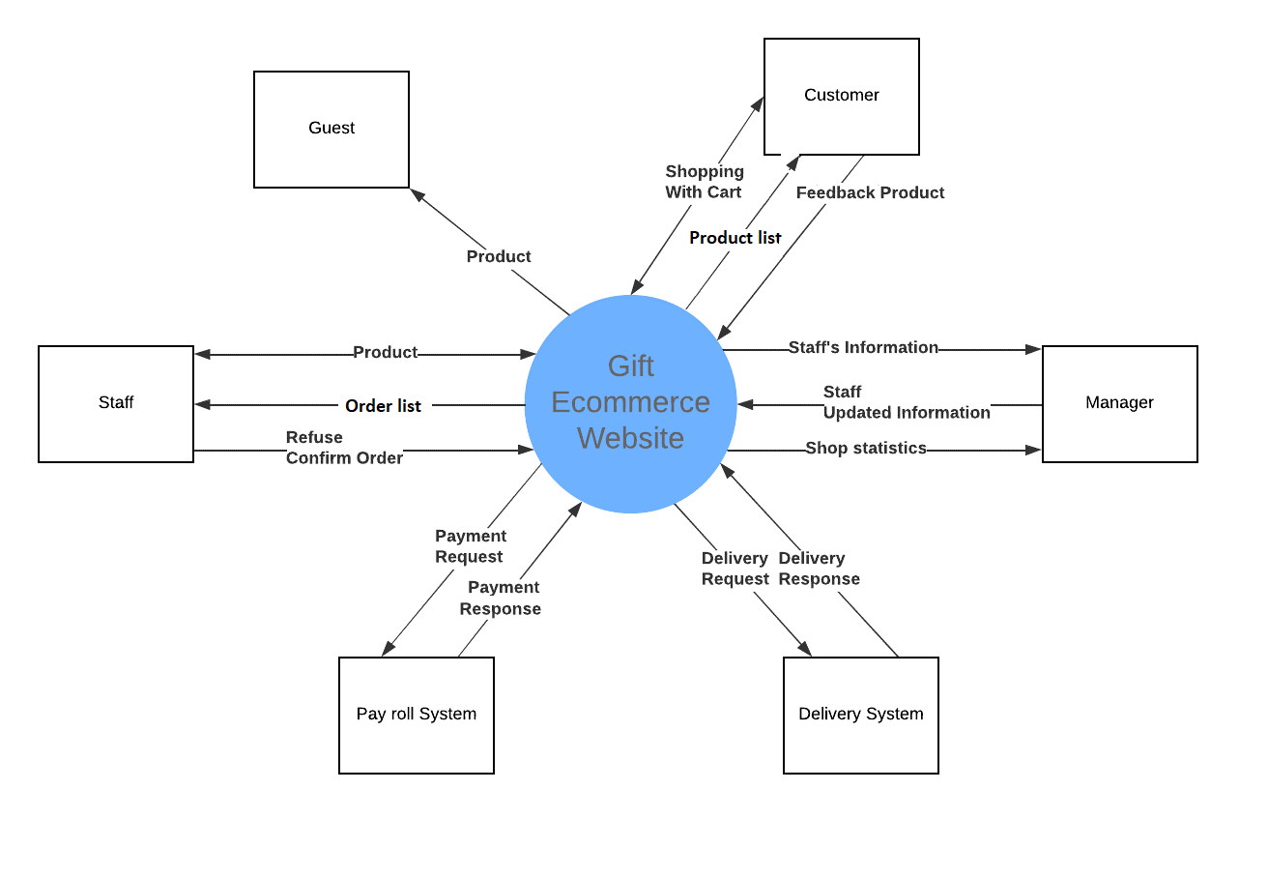

## 2. System Functions

#### a. Screen Flow

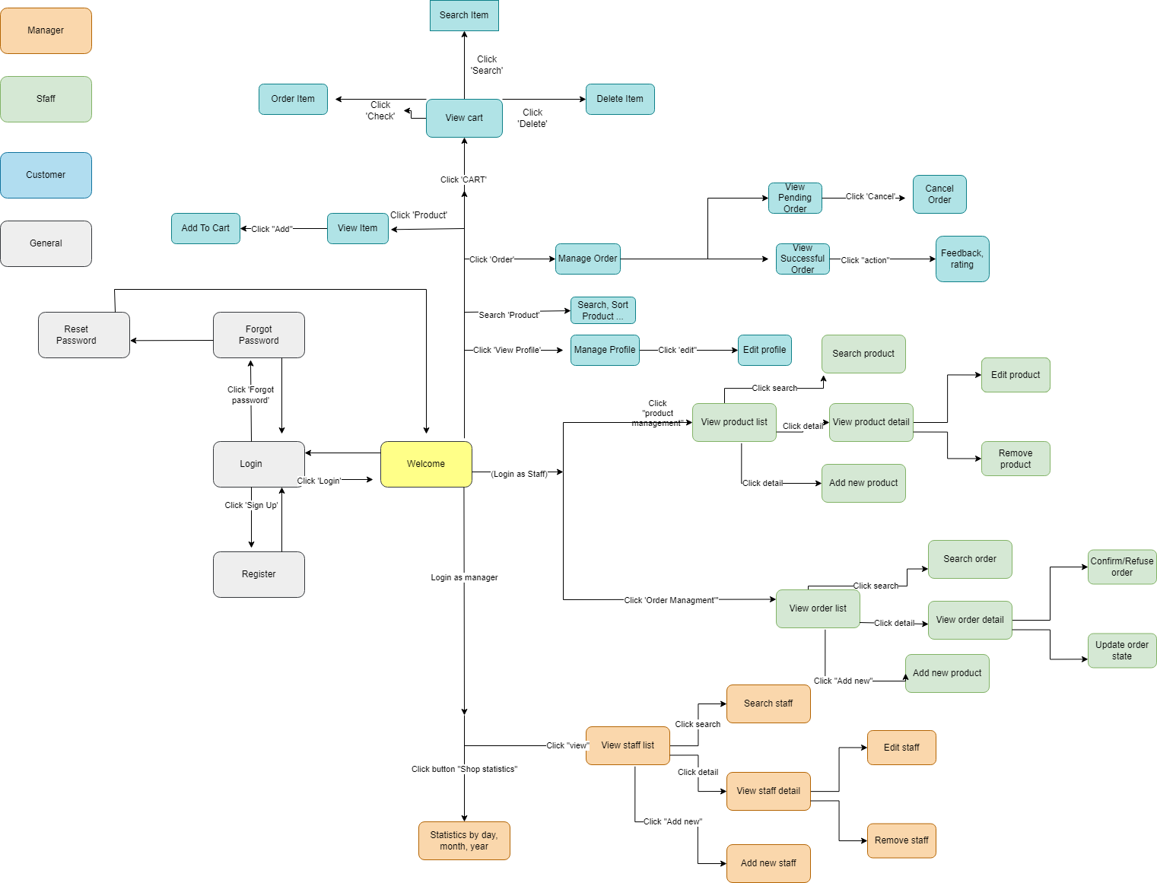

#### b. Screen Details

| **#** | **Feature** | **Screen** | **Description** |
| --- | --- | --- | --- |
| 1 | Home | Home | Default home screen, always accessible |
| 2 | Login | Login, Home | Users can login with a registered or google account, create a new account , reset password and log out. |
| 3 | Manage profile | Profile | Customers can change their information. |
| 4 | Search | Search | Guest, customer can search for products on the website, filter products by name or by price. |
| 5 | Payment | Payment | Customers can choose payments for shopping carts. |
| 6 | Manage Cart | List cart | Customers can add, edit, delete products and view what they choose on the website. |
| 7 | Manage Product | List product | Staff can create, update, and delete products on the website. and view product’s feedback from customers. |
| 8 | Manage Order for Customers | List order | Customers can handle their order for some actions. |
| 9 | Manage Order for staff | List order | Staff can handle the order of customers. |
| 10 | Manage Staff | List staff | Manager can create, update,view and delete staff information. |

#### c. User Authorization

| **Screen** | **Guest** | **Customer** | **Staff** | **Manager** |
| --- | --- | --- | --- | --- |
| Home | X | X | X | X |
| Authentication | X | X | X | X |
| Log in | X |  |  |  |
| Register | X |  |  |  |
| Log out |  | X | X | X |
| Manage account profile |  | X |  |  |
| View profile |  | X |  |  |
| Edit information |  | X |  | X |
| View products in shop | X | X |  |  |
| View product(by sorting by price/sold) | X | X |  |  |
| Search product | X | X | X |  |
| View product by category | X | X | X |  |
| View product details | X | X | X |  |
| Manage product |  |  | X |  |
| View products |  |  | X |  |
| Create Product |  |  | X |  |
| Edit product |  |  | X |  |
| Delete product |  |  |  |  |
| Search product by … |  |  |  |  |
| Manage cart |  | X |  |  |
| View product in cart |  | X |  |  |
| Add product to cart |  | X |  |  |
| Edit quantity of product in cart |  | X |  |  |
| Delete product from cart |  | X |  |  |
| Customer Manage order |  | X |  |  |
| Checkout |  | X |  |  |
| View orders placed |  | X |  |  |
| View detail of each order |  | X |  |  |
| Cancel for pending orders |  | X |  |  |
| Rating/Feedback for successful orders |  | X |  |  |
| Manage staff |  |  |  | X |
| View staff list |  |  |  | X |
| View detail staff profile |  |  |  | X |
| Edit staff profile |  |  |  | X |
| Add new staff |  |  |  | X |
| Delete staff |  |  |  | X |
| Staff Manage order |  |  | X |  |
| View orders placed by customers |  |  | X |  |
| View detail of each order |  |  | X |  |
| Refuse/Confirm orders |  |  | X |  |
| Order State Management |  |  | X |  |
| Statistics |  |  |  | X |
| View statistics by revenue |  |  |  | X |
| View statistics by order |  |  |  | X |
| View statistics by product |  |  |  | X |
| View statistics by user |  |  |  | X |

#### d. Non-Screen Functions

| **#** | **Feature** | **System Function** | **Description** |
| --- | --- | --- | --- |
| 1 | Authentication | Forgot password | System send verification code by email of user for reset password. |
| 2 | Authentication & Authorization | Authentication & Authorization | Using authorization and authentication for APIs. |

## 3. Common Requirements

As a guest, I want to be able to view the product list in the shop, so that I can browse through the available products.

As a guest, I want the option to login or register a new account, so that I can have a personalised experience and access additional features.

As a customer, I want to be able to view the product list and add items to my shopping cart, so that I can easily select the products I want to purchase.

As a customer, I want to be able to place orders and manage them, so that I can keep track of my purchases and review the status of each order.

As a customer, I want the ability to cancel any pending order, in case I change my mind or encounter any issues.

As a customer, I want to provide feedback or rate each product after a successful order, so that I can share my opinion and help other customers make informed decisions.

As a staff member, I want to be able to manage products in the shop by viewing, adding, editing, and deleting them, so that I can ensure the product catalogue is up-to-date.

As a staff member, I want to manage orders from customers by confirming or refusing each received order, so that I can maintain a smooth order fulfilment process.

As a manager, I want to be able to manage staff information, including viewing, adding, editing, and removing staff members, so that I can ensure the team is properly organised.

As a manager, I want to view statistics about products, orders, revenue, and other relevant metrics by day, month, or year, so that I can gain insights into the shop's performance and make informed business decisions.

# 

# II. Functional Requirements

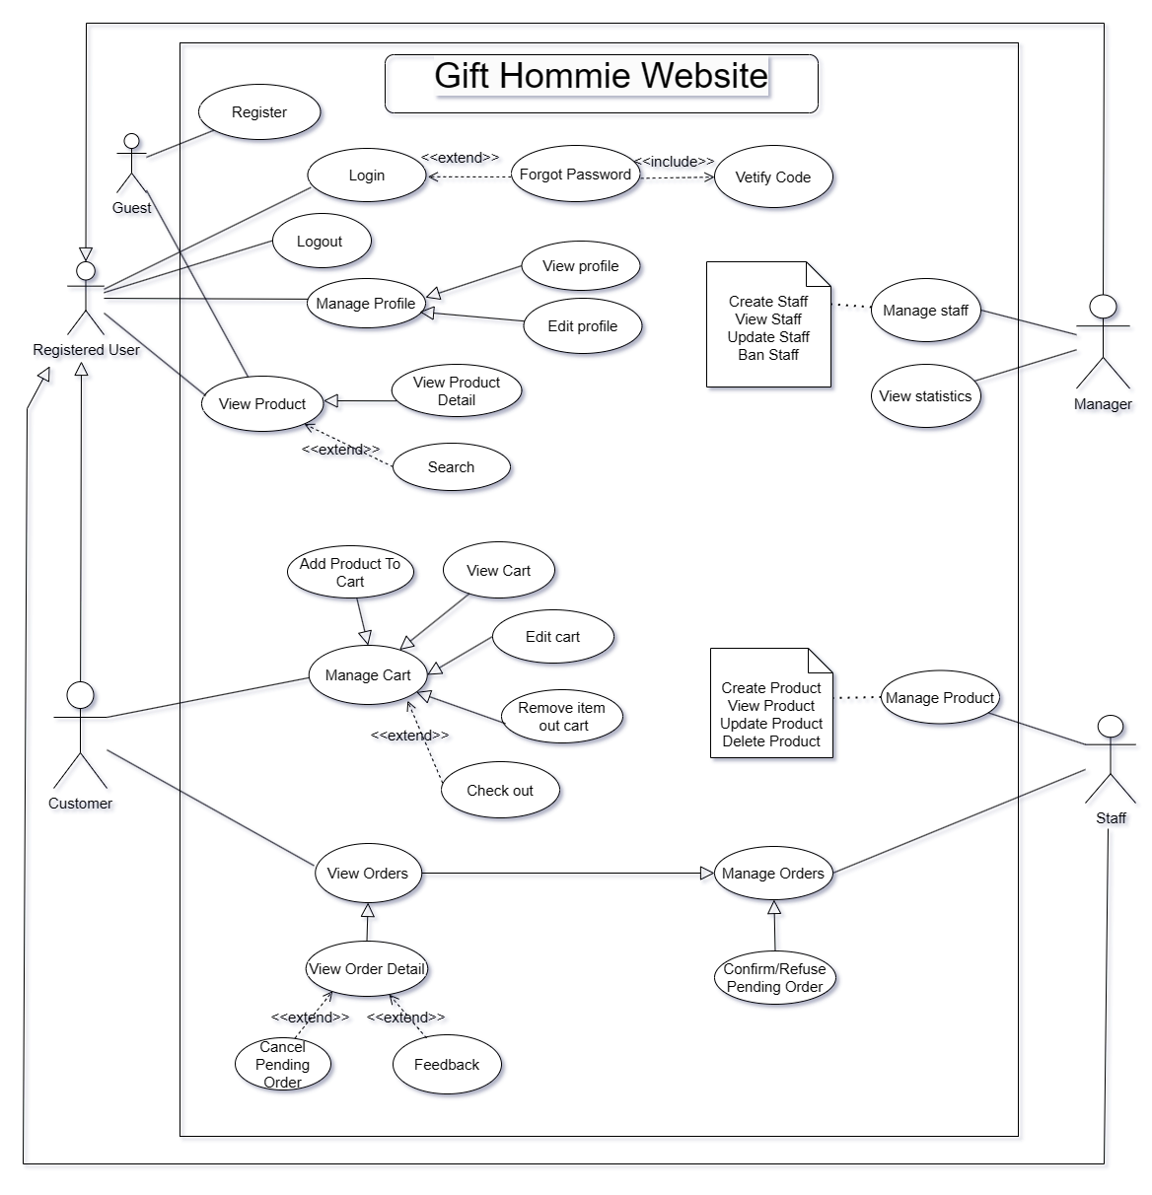

**USE CASE DIAGRAM GIFT HOMMIE WEBSITE**

## 1. <<Home>>

***Function trigger:*** User visit gift hommie website, website will display homepage.

***Function description:*** The Home function serves as the primary interface for users when they launch and access the website. It provides an overview of key features, content, and navigation options, allowing users to easily navigate and access relevant information.

***Screen layout:***

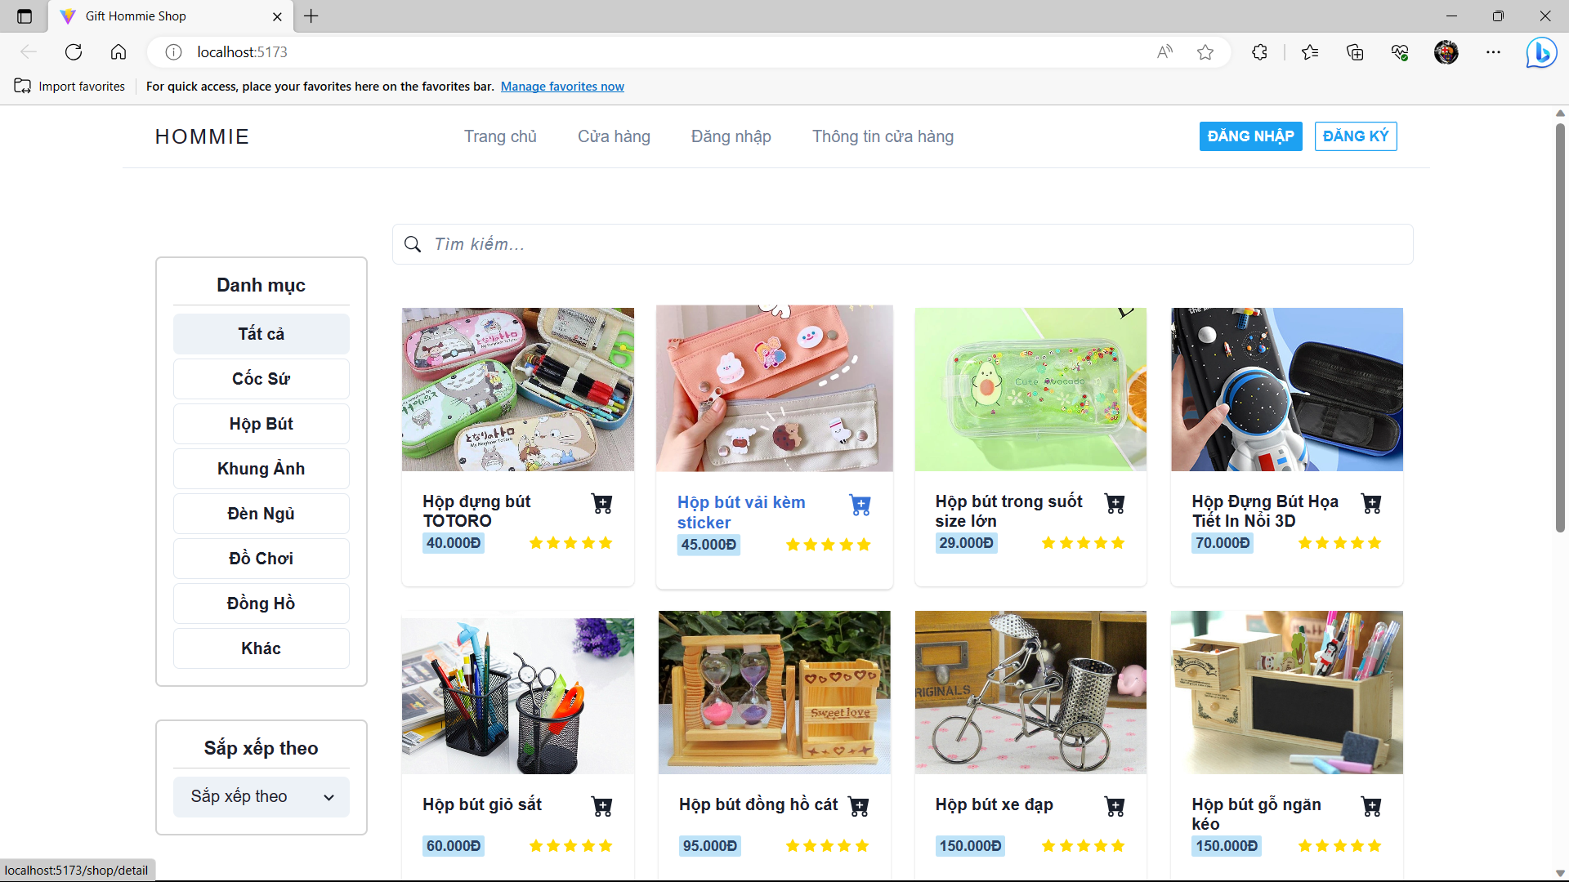

## *Function Details:* Authentication user and guest can use this function.

## 2. <<Authentication>>

## a. <<Login>>

***Function trigger:*** User wants to login by type username,password and click button “Login”, the login function is triggered, and the website starts the authentication and authorization process.

***Function description:*** The login function is a crucial component of an authentication system that allows users to access a computer system, application, or website by verifying their credentials. It typically involves validating the user's identity and granting appropriate access rights.

***Screen layout:***

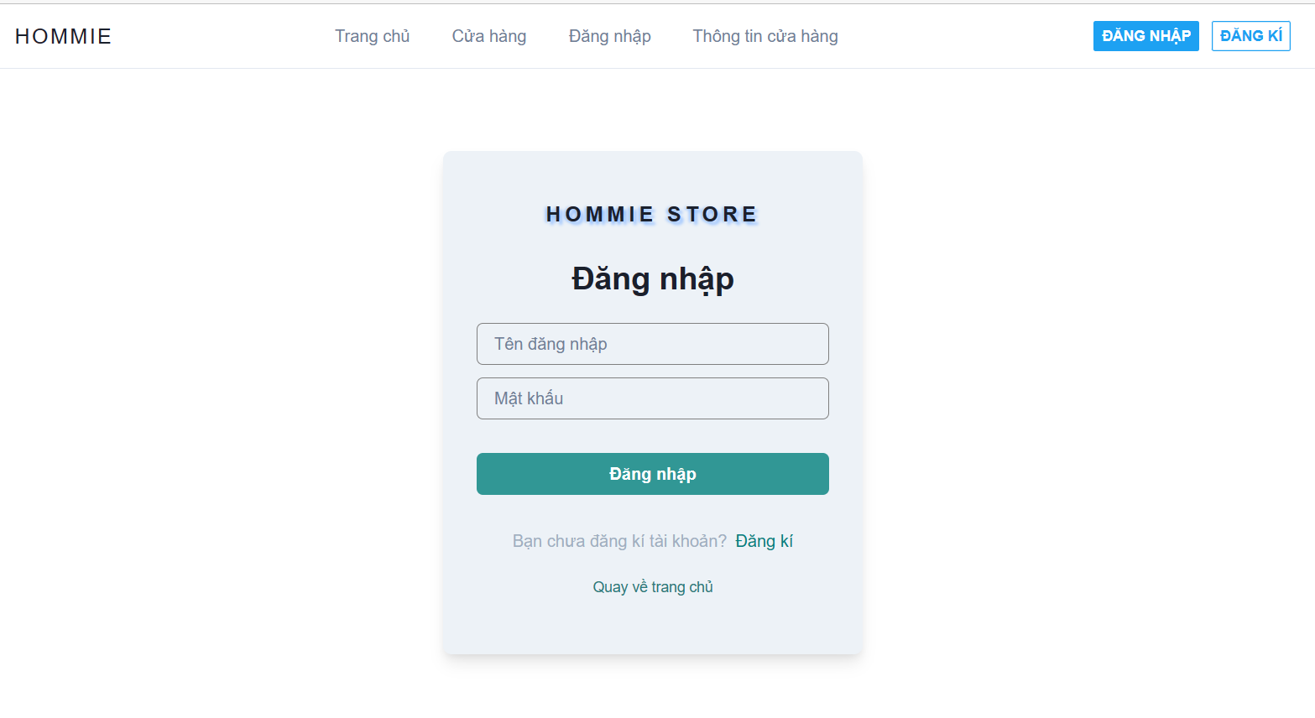

## *Function Details:* User, Staff, Manager must log in.

To ensure the validation of the username and password, it is necessary to check that they are not empty or null.

Accounts have been banned can not login.

## b. <<Sign up>>

***Function trigger:*** Guest wants to sign up, click the “Register” button, the register function is triggered, and the website redirects to the registration form.

***Function description:*** Enables users to create a new account on the platform. It allows individuals to register themselves as customers, providing them with access to various features and benefits offered by the online store. The function collects necessary information from users and creates a unique account associated with their credentials.

***Screen layout:***

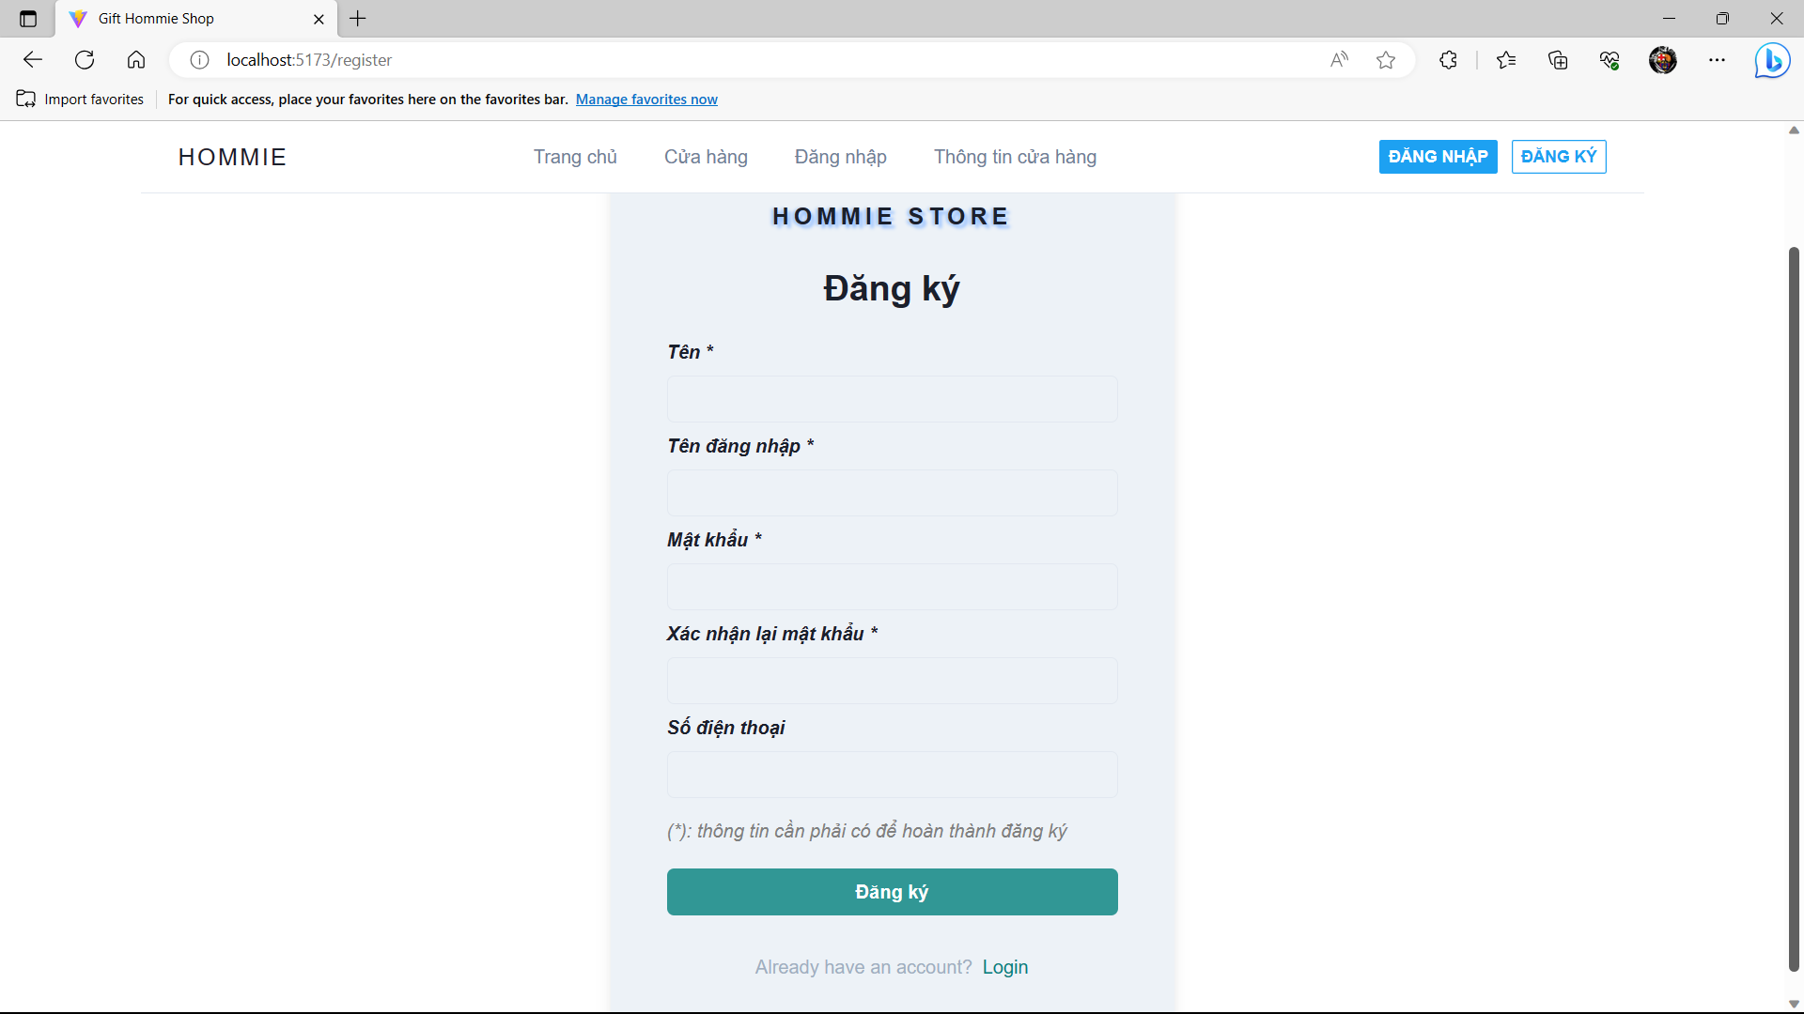

## *Function Details:* Guests must sign up to buy products.

All fields will be validation, username, email and phone is not the same as someone else.

For successful, all field(*) is not empty.

**3. <<Manage Profile>>**

**a. <<View Profile>**>

***Function trigger:***Authentication user can view their profile by click “View profile” button, view profile function is triggered, website redirect them to profile page.

***Function description:***The View Profile function allows users to access and view their personal profile information within the website. It provides users with an overview of their account details, preferences, and any other relevant information associated with their profile.

***Screen layout:***

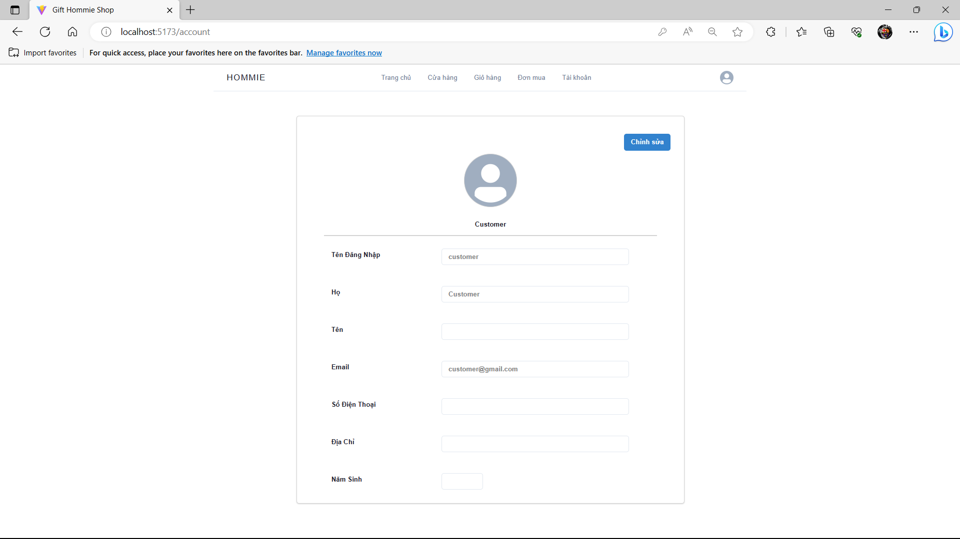

***Function Details****:* Authentication users can use this function.

**b. <<Edit Profile>**>

***Function trigger:***Authentication users can edit their profile by clicking the “Edit profile” button, edit profile function is triggered, website accept user edit profile.

***Function description:***The Edit Profile function allows users to modify and update their personal profile information within the software application or website. It provides users with the ability to change their account details, preferences, and any other relevant information associated with their profile.

***Screen layout:***



***Function Details****:* Authentication users (Except Manager) can edit their profile. They have no ability to edit their username. The password will be shown with password characters and it can be allowed to change.

**4. <<Search>>**

**a. <<View sorted product>**>

***Function trigger:***Users can view sorted products on a website by clicking “Sort by” button, view product function is triggered, website process and display all products consistent.

***Function description:***The "View Sorted Products" function allows users to view a list of products available in the website, sorted according to specific criteria or user preferences.

***Screen layout:***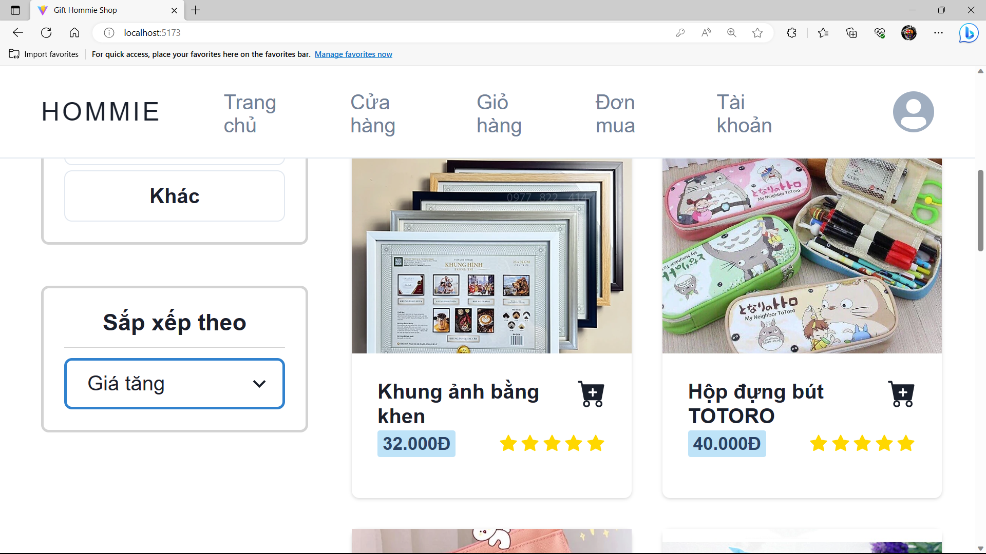

***Function Details****:* View the list of sorted products. The users can choose the property to sort the product list.

**b. <<Search product>**>

***Function trigger:***User can search any product on the website by typing characters in the search box, search function is triggered, website process and display all product consistent.

***Function description:***The "Search Product" function allows users to search for specific products within the website. This function provides users with the ability to enter keywords or specific criteria and retrieve relevant products that match their search query.

***Screen layout:***

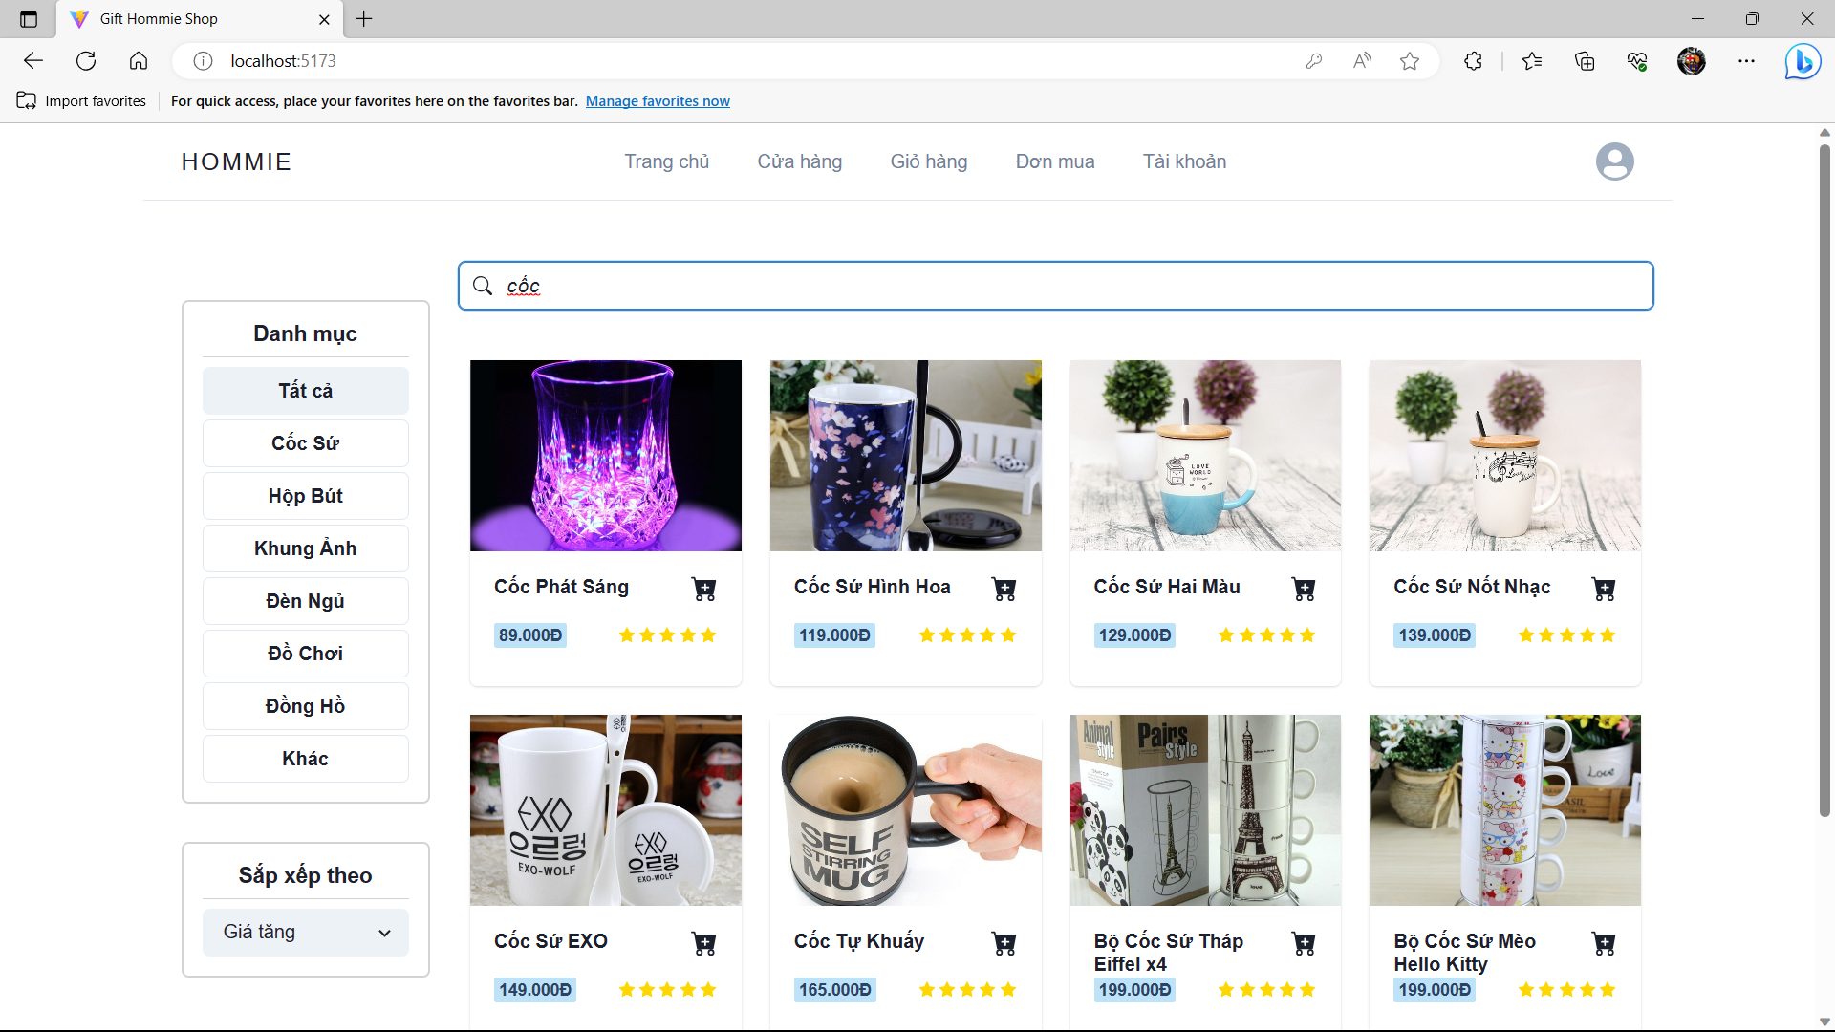

***Function Details****:* Search the product list by product name. The product list will show if the search item contains in each product.

**c. <<Filter product>**>

***Function trigger:***Users can filter any product on the website by clicking the “Filter product” button, filter function is triggered, website process and display all products consistent.

***Function description:***The "Filter Product" function allows users to refine and narrow down their product search results within the website. This function provides users with the ability to apply specific filters or criteria to find products that meet their specific requirements.

***Screen layout:***

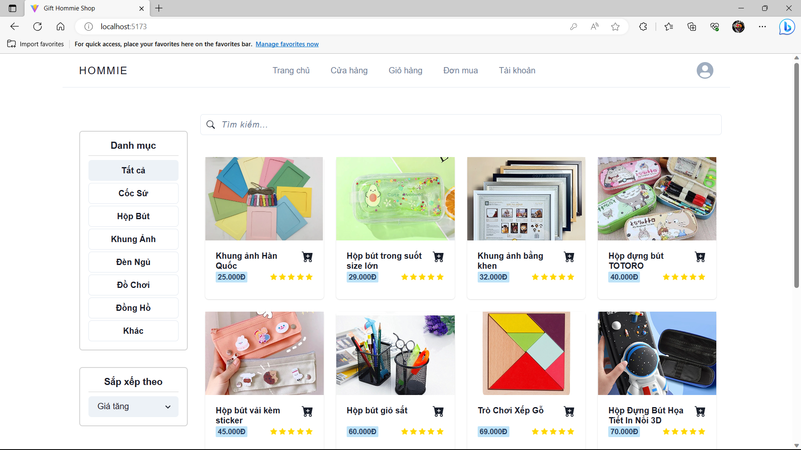

***Function Details****:* Filter the products by their category. The product list will show by their category.

**d. <<View product detail>**>

***Function trigger:***User can view product detail on the website by clicking product, view product detail function is triggered, website display all information about product.

***Function description:***The "View Product Detail" function allows users to access detailed information about a specific product within the website. User can view feedback of product

***Screen layout:*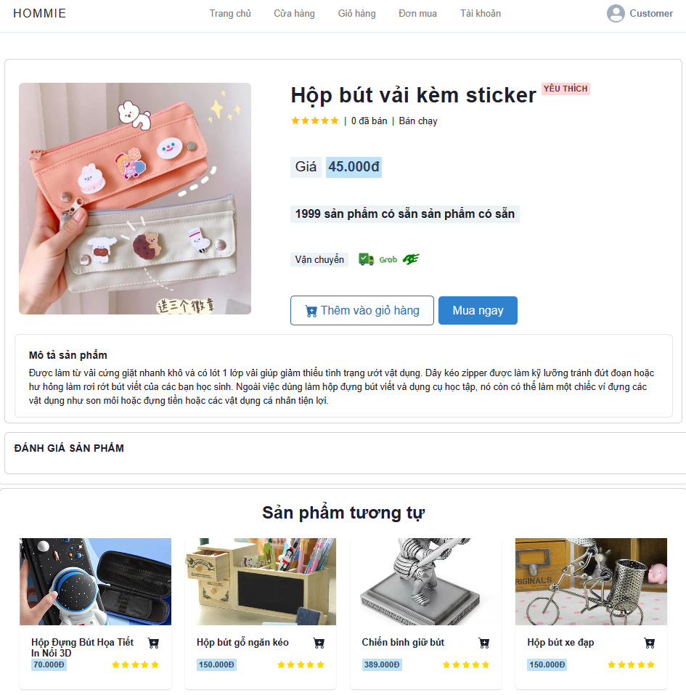**

***Function Details****:* Website not display product detail when product status = false.

Users can not buy products when product quantity = 0.

**5. <<Product Management>>**

**a. <<Create Product>**>

***Function trigger:***Staff wants to Add a new product for business, Staff click button “Tạo mới sản phẩm”, Staff Provide product information and click "Hoàn Tất" button to save the product information.

***Function description:*** "Create Product" function is to allow users to add new items or offerings to a system's database. It typically involves capturing and storing relevant information about the product, such as its name, description, price, quantity, images, category.

**Screen layout:**

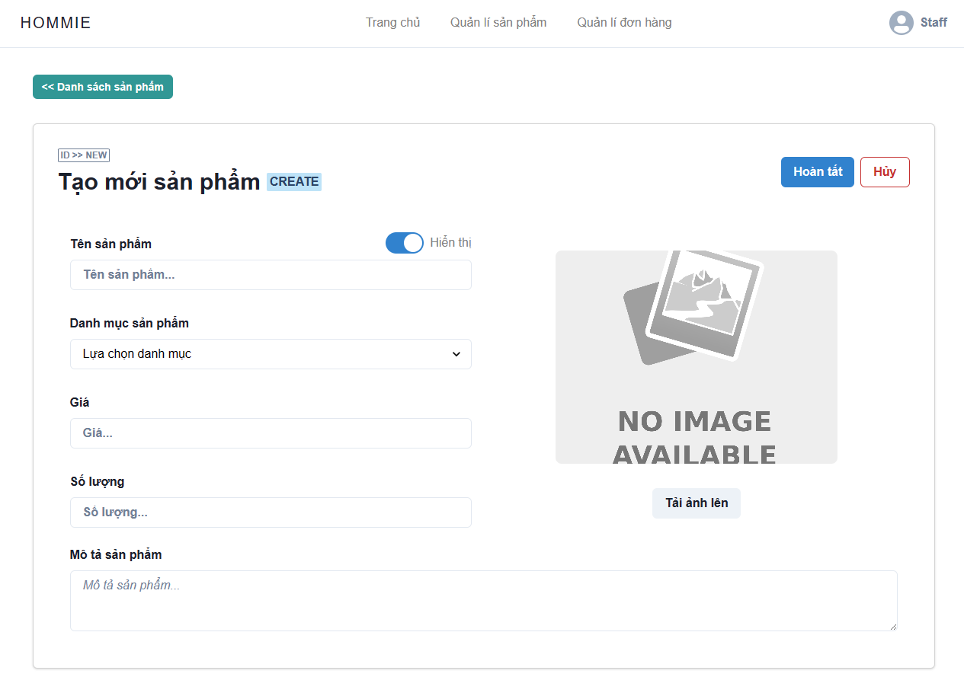

***Function Details****:*

Make sure the new product's data fields are not empty.

Products can only select existing categories.

New products when added new will not have the same primary key as existing products.

Price and quantity of products should not be less than 0.

**b. <<Delete Product >>**

***Function trigger:*** Staff want to delete a product, Staff click button “Xóa” in product detail layout, system show a notification to the system displays a message for the staff to confirm the action to delete the product.

If the staff confirms to delete the product, the product will no longer be displayed in the layouts

​***Function description:*** Staff can delete a exist product base on ID. Product ID will the system will hide the deleted product and will not show it in the user interface

***Screen layout:***

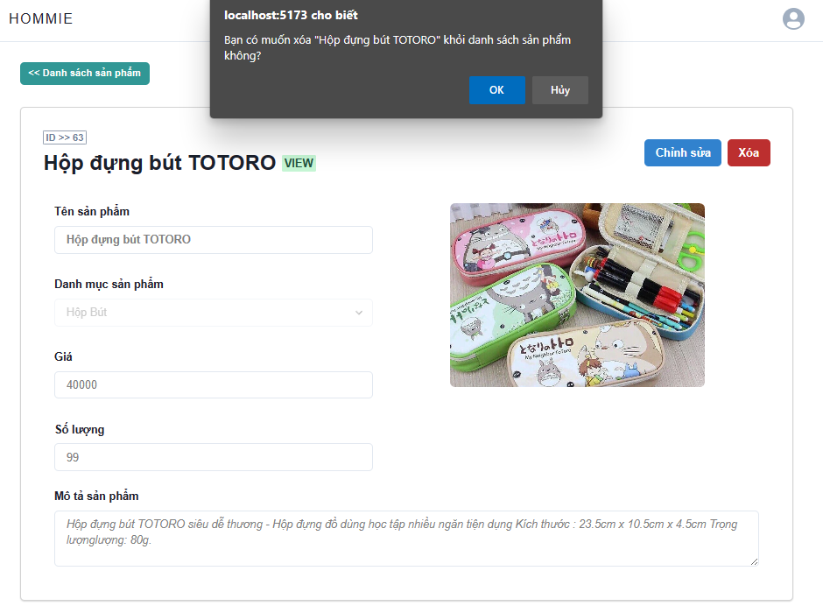

***Function Details****:*

The notice will show the staff of the confirmation of the action to remove the product to avoid any unnecessary confusion.

The product will not be lost in the database, the product will only be hidden under the customer's interface

Customers can still see the products in the previously ordered successfully

**c. <<Edit Product >>**

***Function trigger:***Staff want to editt or update a product, Staff click button “Chỉnh Sửa” in product detail layout. Staff Provide product information and click "Hoàn Tất" button to save the product information.

***Function description****:* Staff can update info an exsit product base on ID. Product ID will be update in database

***Screen layout:****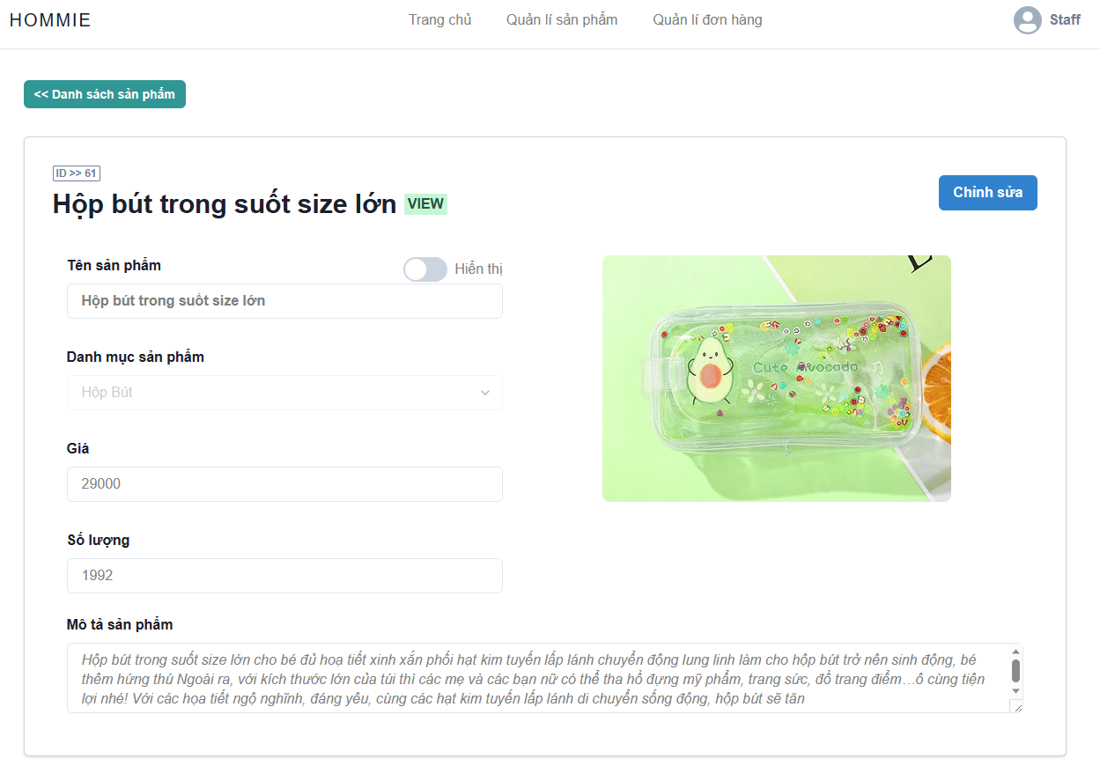*

## *Function Details:*

## The product will be updated with new information after the staff confirms the action to edit the product

## The product information in previously successful special orders is also changed according to the new information.

## The product will display the new information in the customer interface

## 

## **d. <<Upload Product Image >>**

***Function trigger:*** Staff want to change and upload image of product, Staff click button “Tải ảnh lên” in product detail layout, Staff will load new Image of Product and click button “Cập Nhật” to save new image.

***Function description****:* Staff can update info an exsit product base on ID. Product ID will be update in database

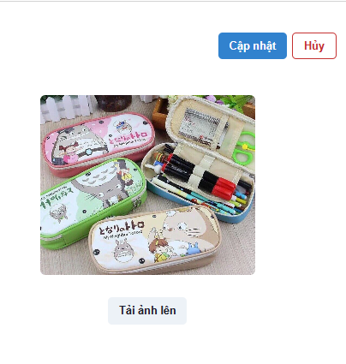

***Function Details****:*

The product will be updated with new information after the staff confirms the action to edit the product

The product information in previously successful special orders is also changed according to the new information.

The product will display the new information in the customer interface

**6. <<Manage Cart>>**

**a. <<Add To Cart>>**

***Function trigger:*** Customer want to add to cart a product they like, Customer will click button “Add To Cart”, Customer can add product more one time. Function Add To Cart trigger.

***Function description:***  Function is responsible for adding products to the user's shopping cart. The function retrieves the necessary information about the selected product and adds it to the user's shopping cart object

***Screen layout:***

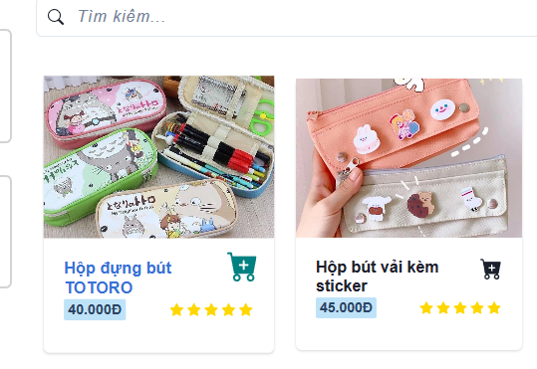

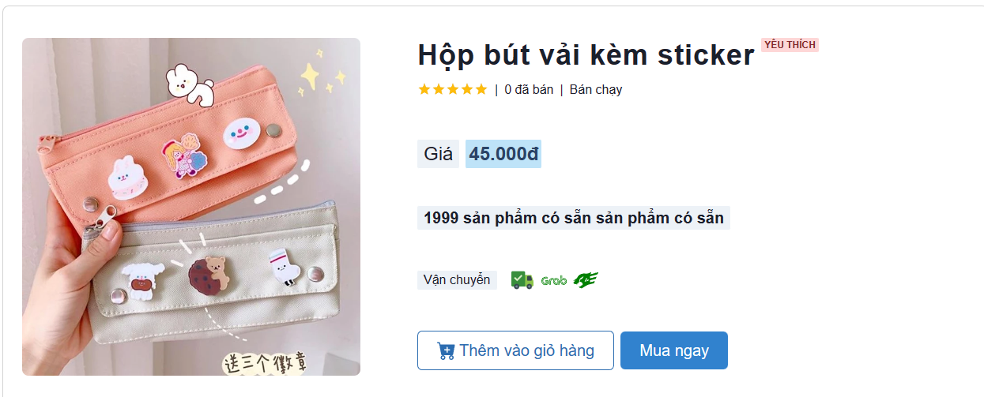***Function Details:***

## User can add to cart products multiple times

## The quantity that the user can put in the cart will not be allowed to exceed the quantity available in the database

## The products that the user has selected will be retrieved through the Product table and put into the Cart table in the database

**b. <<Delete Product From Cart>>**

***Function trigger:*** Customer want to remove a product in cart, Customer will click on button “remove” on Cart layout, Product will disappeared in the customer's shopping cart. Delete product function trigger.

***Function description:***  "Delete Product From Cart" refers to the action of removing a specific item from a user's online shopping cart. This action is typically taken when the user no longer wants to purchase the product or has decided to remove it from their order for any other reason.

***Screen layout:***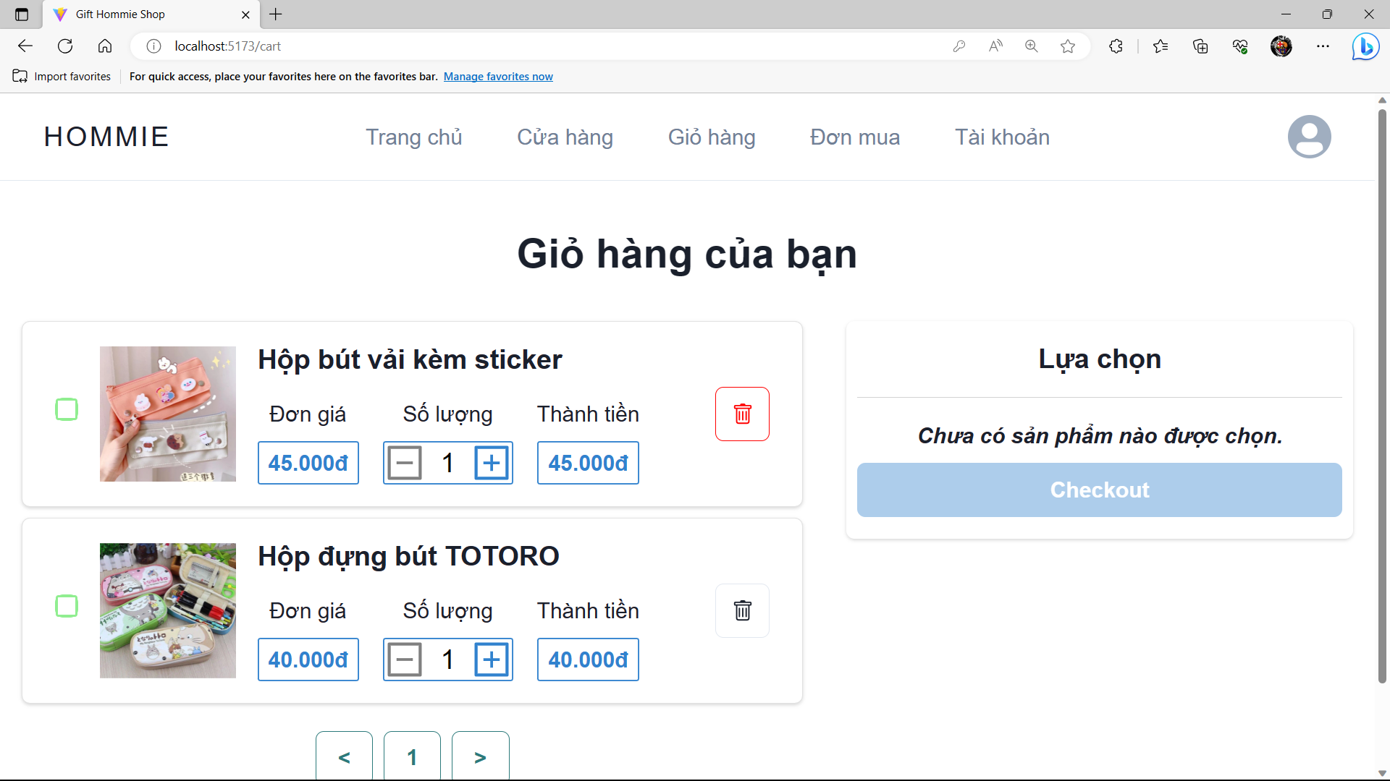

## *Function Details:*

Product will disappeared in the customer's shopping cart.

## The quantity that the user can put in the cart will not be allowed to exceed the quantity available in the database

## The products that the user has selected will be retrieved through the Product table and put into the Cart table in the database

**c. <<View Product in Cart>>**

***Function trigger:*** Customer wants to see the products already in the cart

***Function description:*** The "View Product in Cart" function is a feature that allows users to see the products they have added to their online shopping cart. This function is important as it helps users keep track of their orders and make any necessary changes before proceeding to checkout.

***Screen layout:***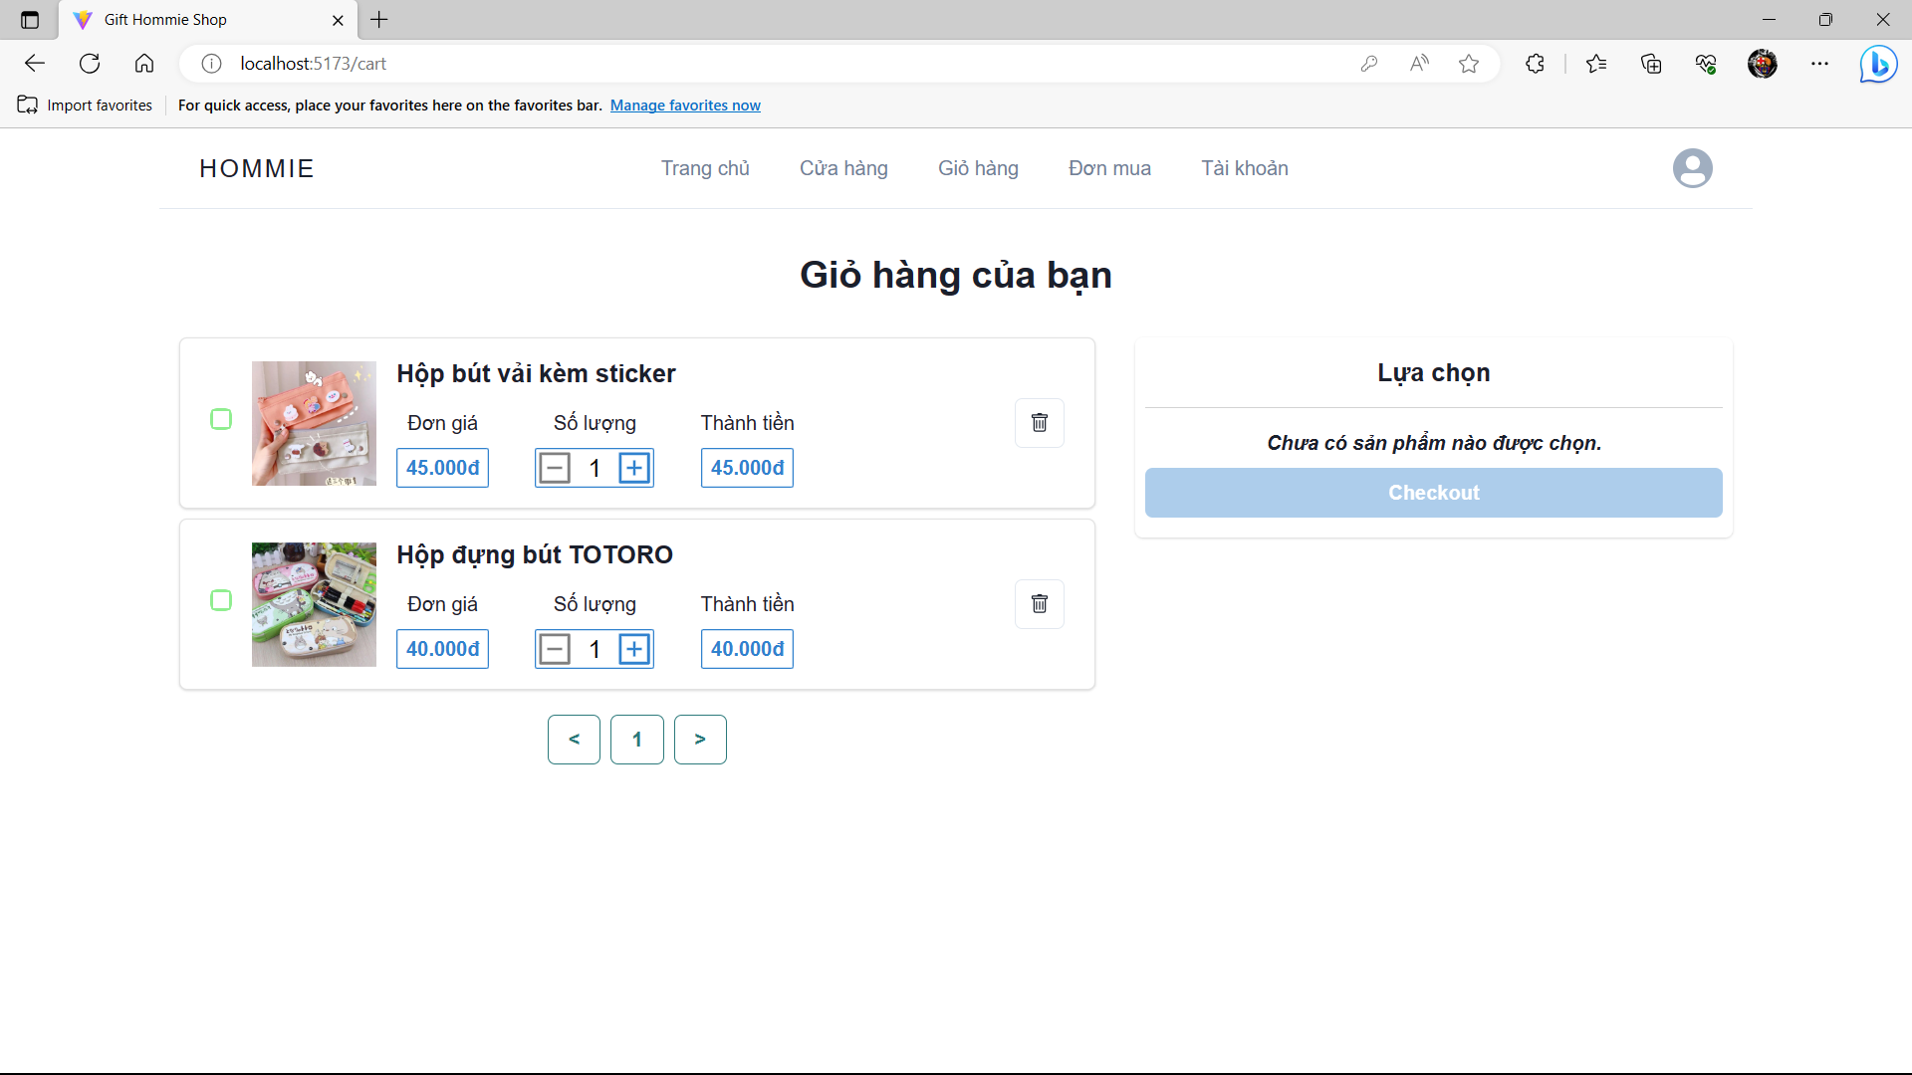

## *Function Details:*

## The user can view a list of products and can split them into multiple pages if the product the user ordered is too large.

## The products displayed in the cart will provide the detailed information of that product

## The quantity that the user can put in the cart will not be allowed to exceed the quantity available in the database

## The products that the user has selected will be retrieved through the Product table and put into the Cart table in the database

**d. <<Edit Quantity of Product in Cart>>**

***Function trigger:*** Customer wants to change quantity of the products already in the cart. Customer click button “+” or “-” to to adjust the amount appropriate to user needs.

***Function description:*** The "Edit Quantity of Product in Cart" function that allows users to adjust the number of products they have added to their online shopping cart. This function is important as it helps users manage their orders and ensure that they purchase the correct amount of each product.

***Screen layout:***

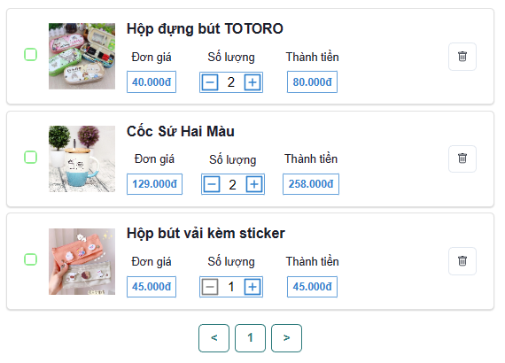

***Function Details:***

The user can view a list of products and can split them into multiple pages if the product the user ordered is too large.

The products displayed in the cart will provide the detailed information of that product

The quantity that the user can put in the cart will not be allowed to exceed the quantity available in the database

The products that the user has selected will be retrieved through the Product table and put into the Cart table in the database

**7. <<Order Management (Customer)>>**

**a. <<Select products to prepare order>>**

***Function trigger:*** Customer want to select the list of products with quantity to prepare to buy, Customer click into check box of product, product selected will put on products will pay.

***Function description:*** The function will help customers select the list of products with quantity to buy to prepare to buy.

***Screen layout:***

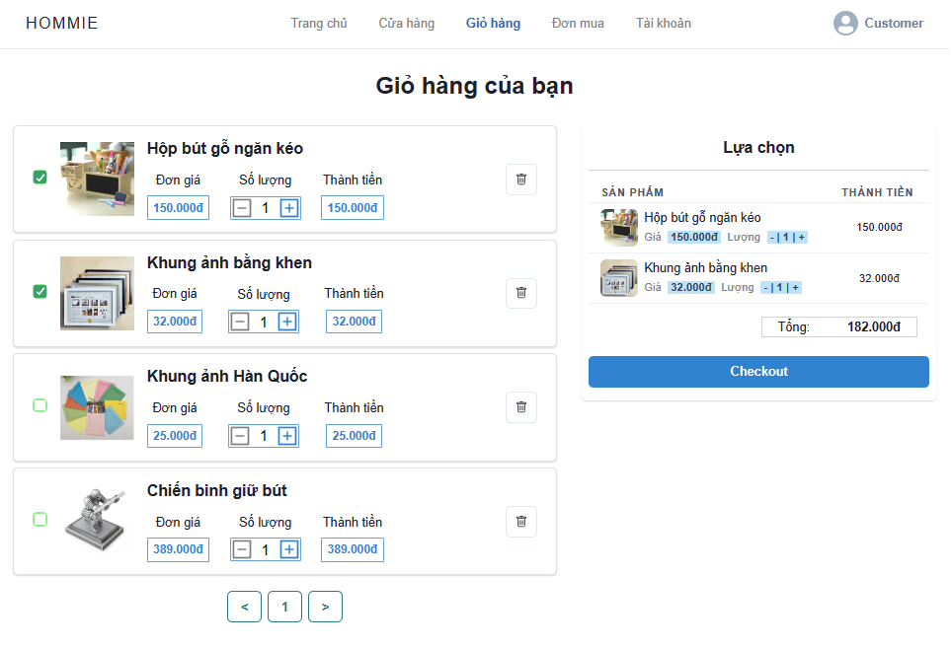

## *Function Details:*

## The user can view a list of products and can split them into multiple pages if the product the user ordered is too large.

The quantity that the user can put in the cart will not be allowed to exceed the quantity available in the database

The products that the user has selected will be retrieved through the Product table and put into the Cart table in the database

**b. <<Complete order information to order>>**

***Function trigger:*** The customer will provide the information for the payment process, the user will choose the payment method and delivery method and click the "Payment" button.

***Function description:*** The "Complete Order Information to Order" functionality enables customers to edit quantity to successfully place an order.

***Screen layout:***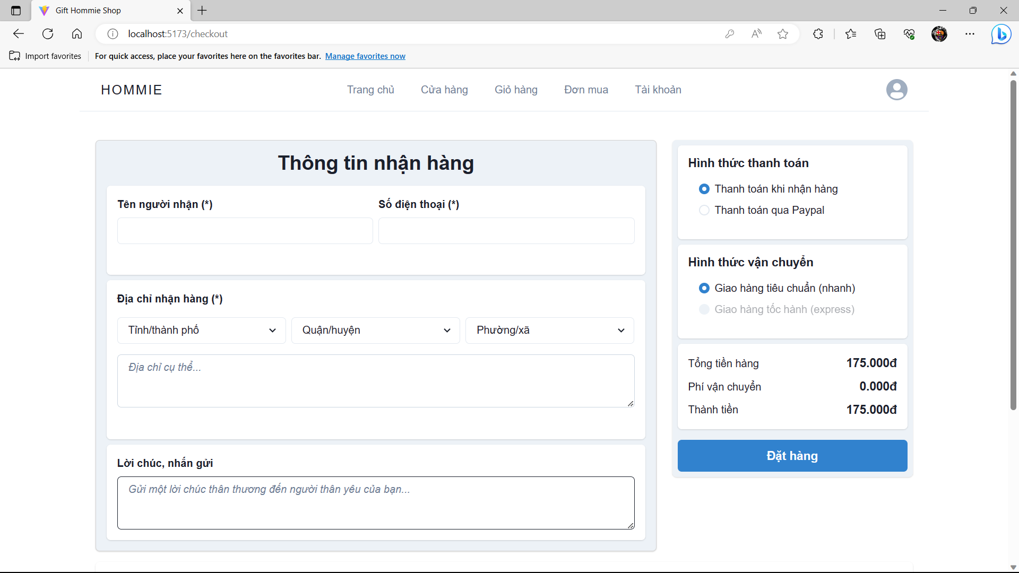

## *Function Details:*

Function make sure the customer data fields are not empty.

Shipping costs are calculated based on the user's location.

User cost of getting API from a 3rd party.

Ensure accuracy and confidentiality of customer's personal information

**c. <<View Order Placed>>**

***Function trigger:*** Customer wants to view the list of ordered. Customer can view ordered click on the status of the order. The system activates the View Order function and displays a list of orders by status.

***Function description:*** The "View Order Placed" functionality allows customers to access and review the basic information of an order that was ordered. This feature provides a convenient way for customers to manage the order

***Screen layout:***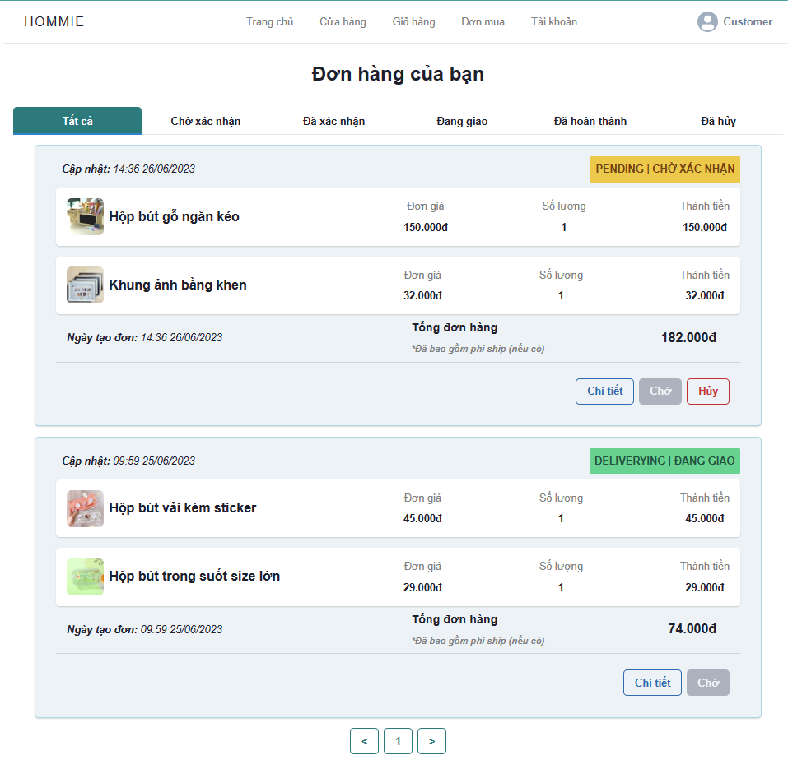

## *Function Details:*

## View all the order list that customer ordered with pageable page.

Customers can only cancel pending orders.

Customers can view order details with products in order details

After the system's products are changed, the user's order will also be updated

**d. <<View The Details of Order>>**

***Function trigger:*** Customer wants to view the details’ information of order, Customer click button “Chi Tiết”, View Detail Order function will trigger and show information and status of order the order the Customer has selected.

***Function description:*** The "View Order Details" functionality allows users to access and review the specific details of a previously placed order. This feature provides users with a convenient way to retrieve important information about their orders.

***Screen layout:***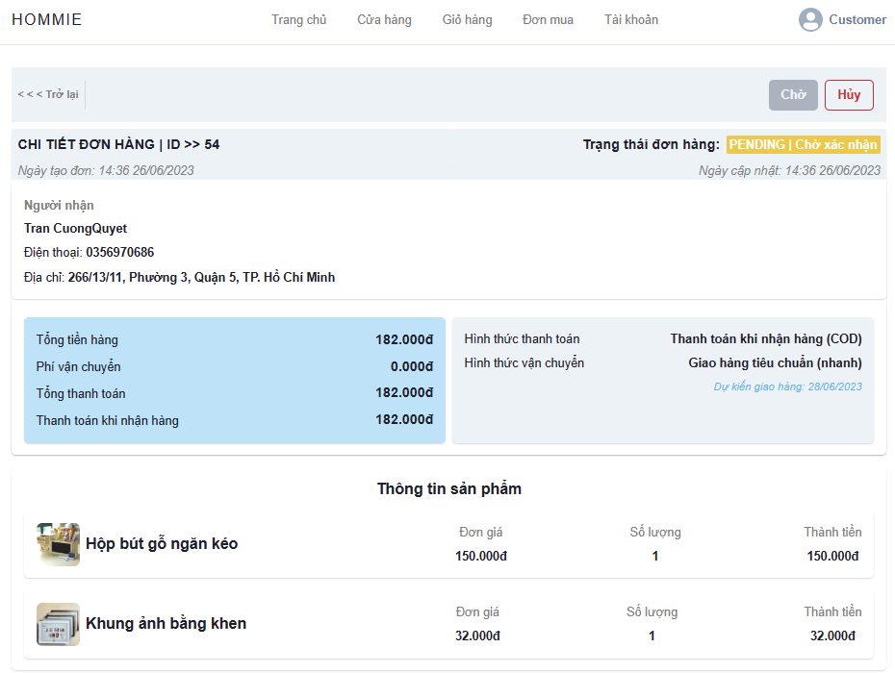

## *Function Details:*

## View all the detailed information of order. The order was identified by order id, if the order doesn’t exist, system show “ORDER DOESN’T EXIST”.

The information of the product will always match the information provided by the user.

Order status can be automatically updated

After the order is updated the user will receive a notification at the time that the order status changes

**e. <<Cancel the Pending Order>>**

***Function trigger:*** Customer wants to cancel a pending order

***Function description:*** The "Cancel Pending Order" functionality allows users to request the cancellation of an order that is in a pending state, typically before it has been processed or shipped.

***Screen layout:***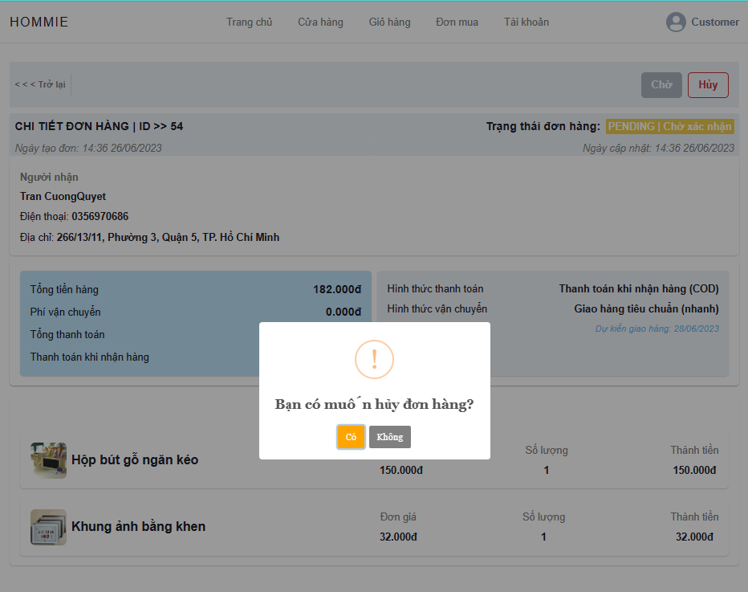

## *Function Details:*

## Customer CANNOT cancel the order that was in PENDING.

Order status can be automatically updated

After the order is updated the user will receive a notification at the time that the order status changes

**f. <<Rating/Feedback the Successful Order>>**

***Function trigger:*** Customer wants to rate and send feedback about a product or service that they used. Customer click button “Đánh Giá”, Rating/Feedback function will trigger. Customer can provide their reviews as well as their reviews of the product.

***Function description:*** The "Rating or Feedback for Successful Orders" functionality allows users to provide ratings and feedback for orders that have been successfully fulfilled. This feature enables users to share their experiences, express satisfaction, and provide valuable insights to businesses.

***Screen layout:***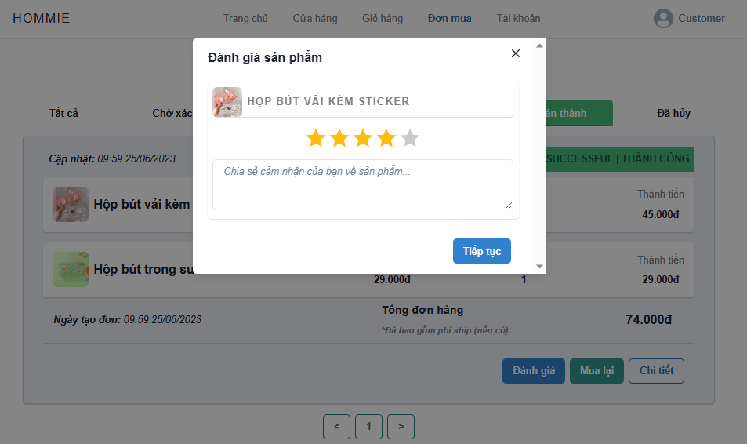

## *Function Details:*

## Customers can only rate products once of each product purchased by the user

## Customers will be able to rate the product after the order is in a successful delivery status

## Other customers can see comments that users who have purchased the product have commented on

**8. <<Staff Management>>**

**a. <<View Staff List>>**

***Function trigger:*** When the manager clicks the button ‘Staff Management’ in the header, the staff management function is triggered. The list of staffs wil be shown

***Function description:*** The view staff function will help the manager view the list of staff with a pageable page.

***Screen layout:  
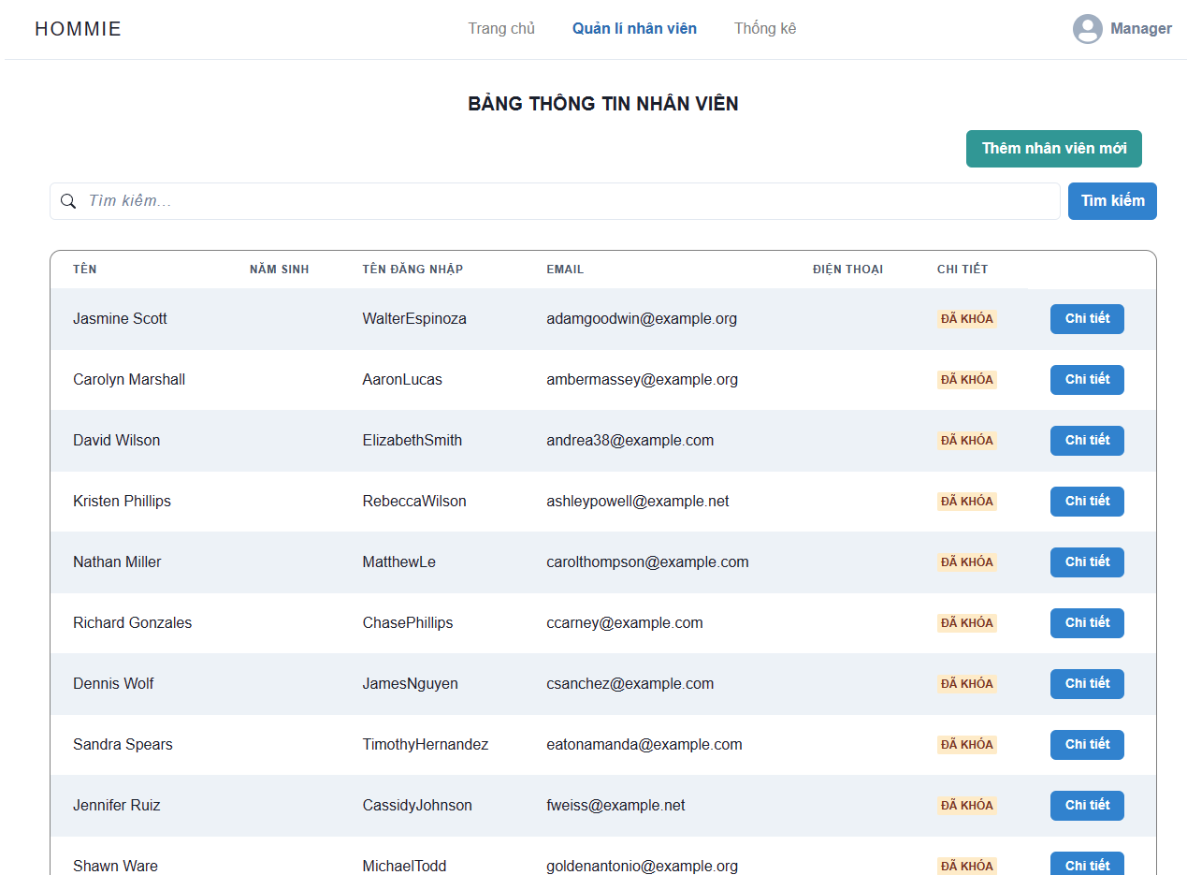***

## *Function Details:* Cannot show the staff banned. Almost all information about the staff account will be shown except status.

**b. <<View detailed staff’s profile>>**

***Function trigger:*** When Manager clicks the button ‘Details’ of the staff wanted to view profile, the function will be triggered. New page showing the details of information about the staff will be shown.

***Function description:*** The function will help managers view the detailed information of staff by username or email. The information that is shown is such as username, email, phone number, full name, etc. The staff account was identified by their username or email

***Screen layout:***

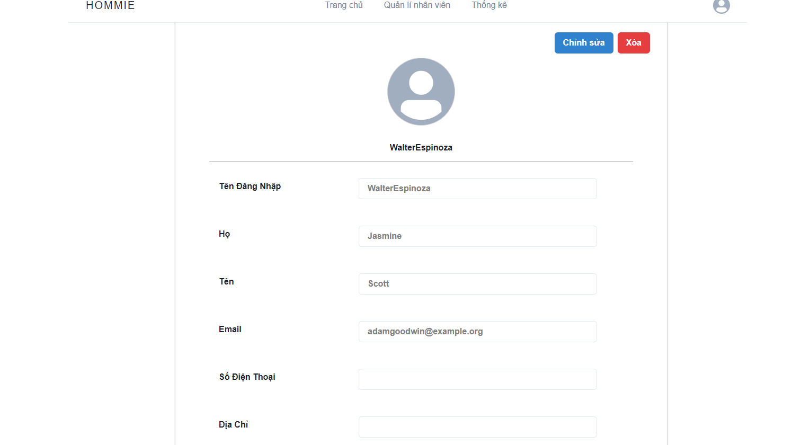

## *Function Details:* Manager can view the details of staff’s information who is visible. The page of staff details show almost all information about the staff except password and status.

**c. <<Edit Staff Profile >>**

***Function trigger:*** When the manager clicks the button ‘Edit’ in the top right corner in the staff details page, the function will be triggered. The manager can have the ability to edit the staff profile.

***Function description:*** The function will help managers edit a staff’s profile that exists if the staff account information is not right. The staff account was identified by their username or email

***Screen layout:***

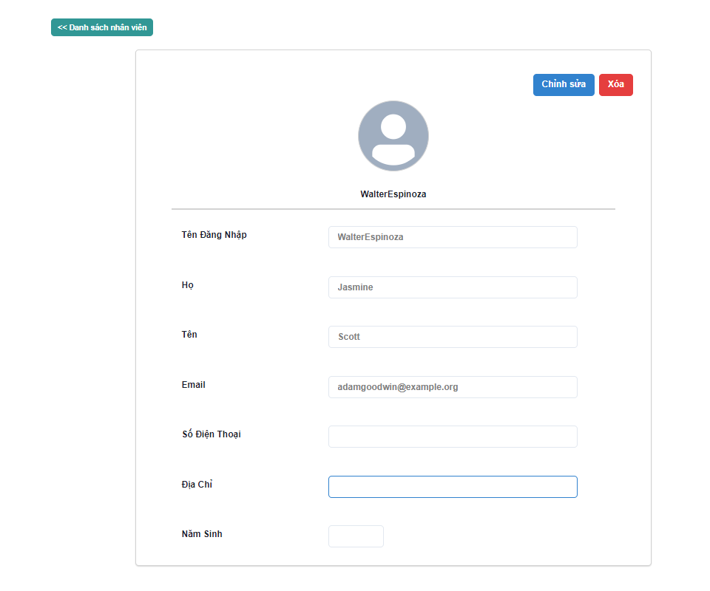

## *Function Details:* The Manager does not have the permission to edit the username and password of staff. The email cannot be duplicated. Email, name cannot be empty.

**d. <<Add a new staff>>**

***Function trigger:*** When the manager clicks ‘Add a new staff’ in the staff management page, a new page will be shown. This page allows the manager to type the information of staff before they click ‘Add’. A new staff account will be stored.

***Function description:*** The function will help managers create a new staff account by some given information of the staff.

***Screen layout:***

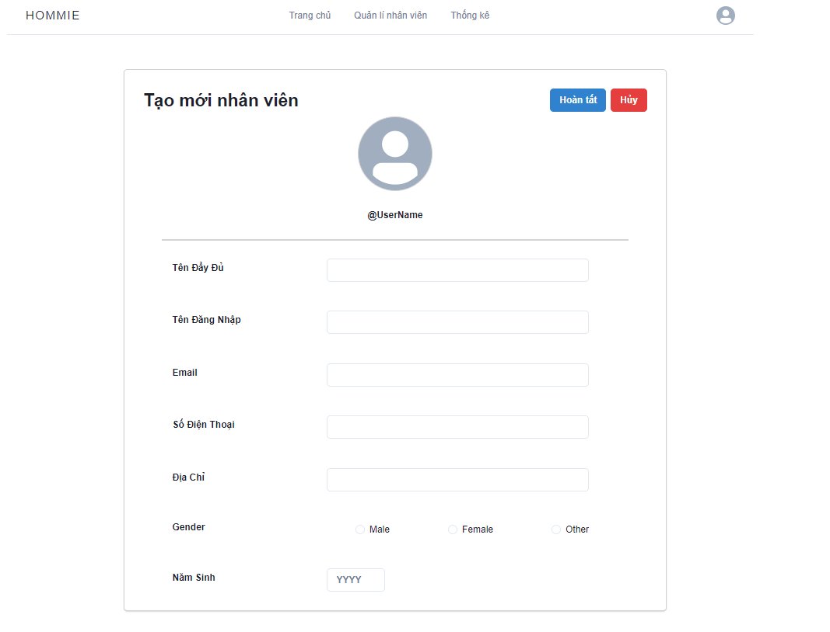

## *Function Details:* The given information are username, email, phone number, address, year of birth, gender, etc. Username and email cannot exist. All fields of account cannot be empty.

**e. <<Delete a staff>>**

***Function trigger:*** Manager wants to delete staff

***Function description:*** The function will help managers delete or ban a staff account because of some reasons. The staff account was identified by their username or email

***Screen layout:***

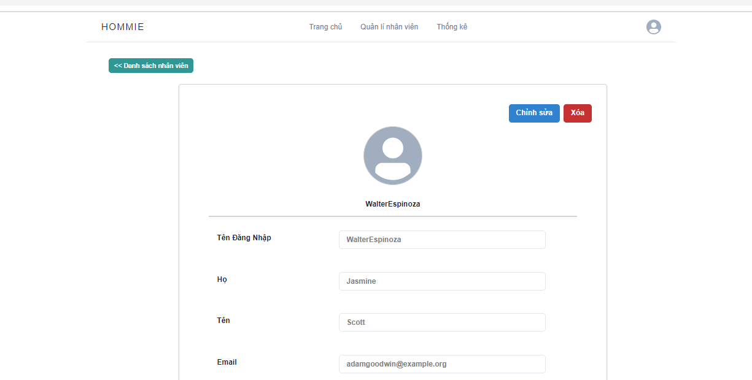

## *Function Details:* The confirm message will be shown. The status of the staff account will be changed to false and they will not be visible.

**9. <<Order Management (staff)>>**

**a. <<View order placed >>**

***Function trigger:*** When the staff clicks ‘Order Management’, the function will be triggered. The page of order management will be shown.

***Function description:***.The "View Order Placed" function is designed for staff members within a system or platform to access and review orders that have been placed by customers. It provides staff members with the necessary information about each order, allowing them to track the progress of the order and manage related tasks effectively.

***Screen layout:***

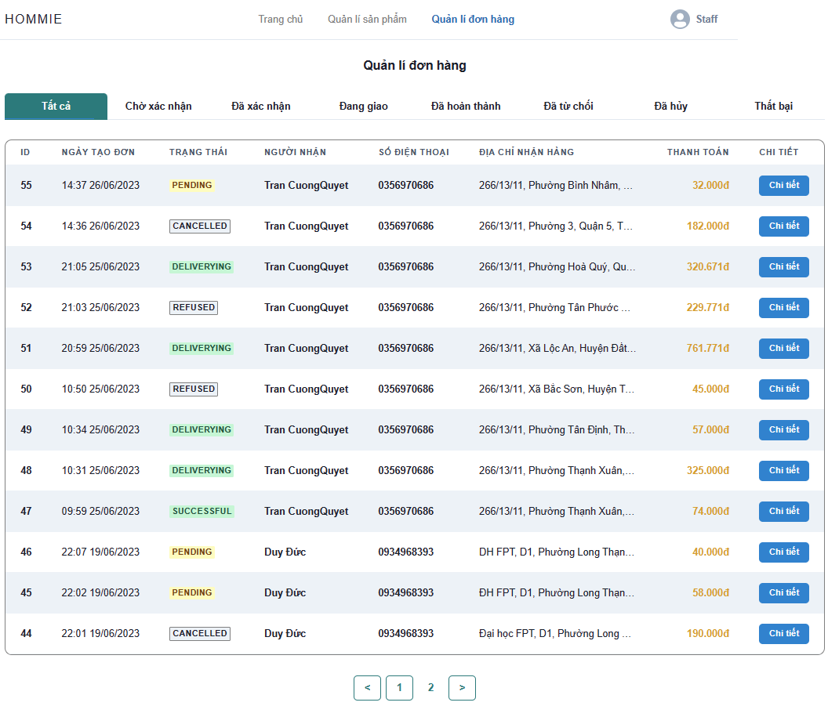

## *Function Details:* All orders with all status will be shown. All information of order will be visible. The order list will be shown by order by their order time.

**b. <<View detail of each order>>**

***Function trigger:*** When the staff clicks ‘Details’ of an order, the function is triggered. A page showing the detailed information of order will be displayed.

***Function description:***.The viewOrderDetail function is responsible for displaying the detailed information of a specific order. It provides staff members with a comprehensive view of each order, including itemised lists of products or services ordered, quantities, prices, payment information, shipping details, and any other relevant information associated with the order.

***Screen layout:***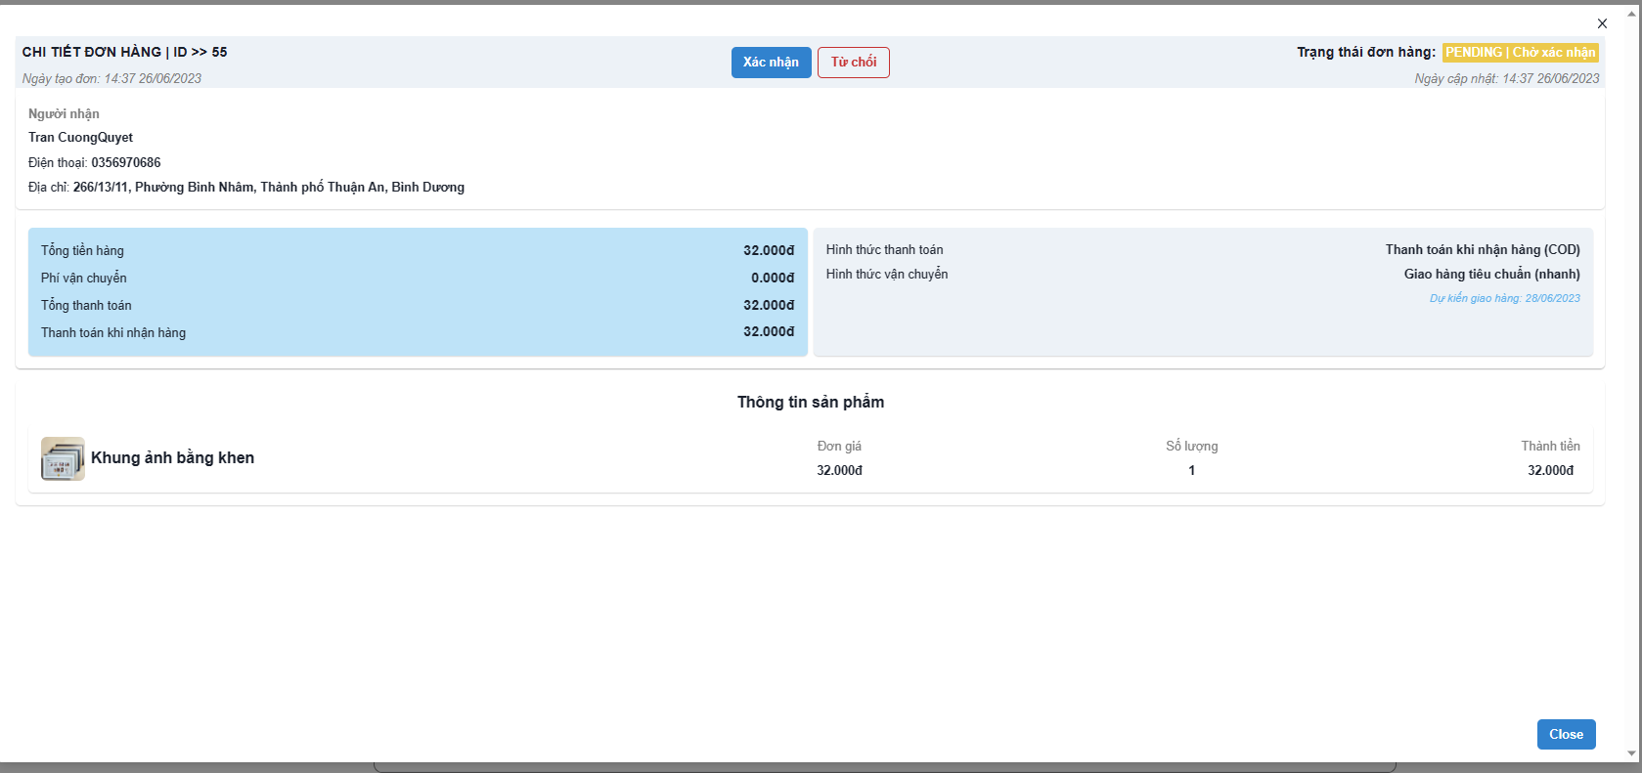

## *Function Details:* All Information and order details of an order will be shown.

**c. <<Refuse/confirm order>>**

***Function trigger:*** When the staff view the order detail, the staff click ‘Refuse’ or ‘confirm’ to trigger the function. The order will be refused or confirmed.

***Function description:***The manageOrder() function handles the process of confirming or refusing an order based on the staff member's decision. This function allows staff members with the appropriate role and permissions to take action on an order, either confirming it for further processing or refusing it.

***Screen layout:***

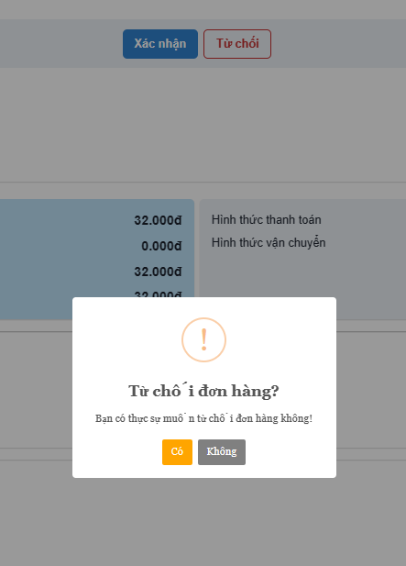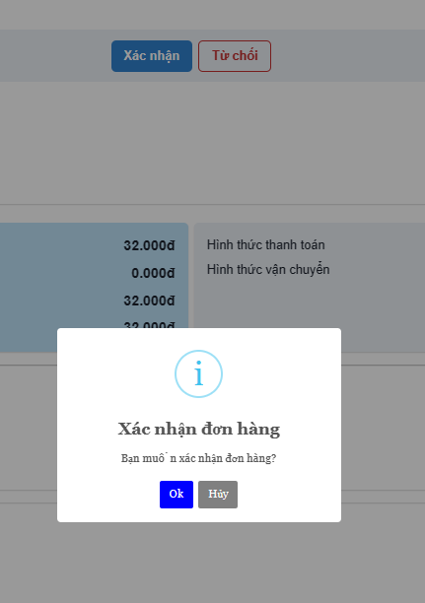

## *Function Details:* The confirm message will be displayed when the button is clicked. The status of order will change to ‘CONFIRM’ or ‘CANCELLED’

**10. <<Statistic>>**

**a. <<View Statistics by Revenue>>**

***Function trigger:*** The default page of the manager page will display the overview of statistics. When the manager clicks ‘Revenue’, the function will be triggered.

***Function description:*** The specific method for viewing revenue may vary depending on the source of the information and the format in which it is presented

***Screen layout:***

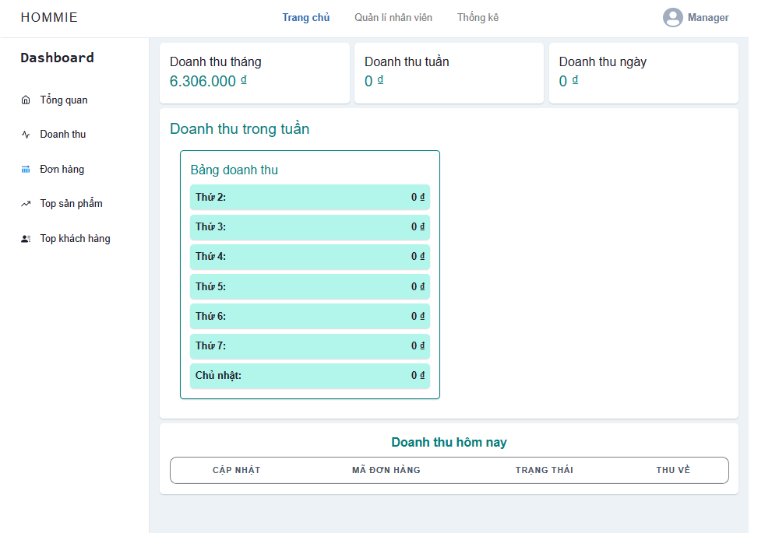

## *Function Details:* View the revenue of the store by day, week, month and quarter

**b. <<View statistics by product>>product**

***Function trigger:*** The default page of the manager page will display the overview of statistics. When the manager clicks ‘Order’, the function will be triggered.

***Function description:*** This function retrieves and displays statistics and metrics related to a specific product or a set of products. It takes input parameters such as the product identifier, time range, or any other relevant filters to narrow down the data.

***Screen layout:***

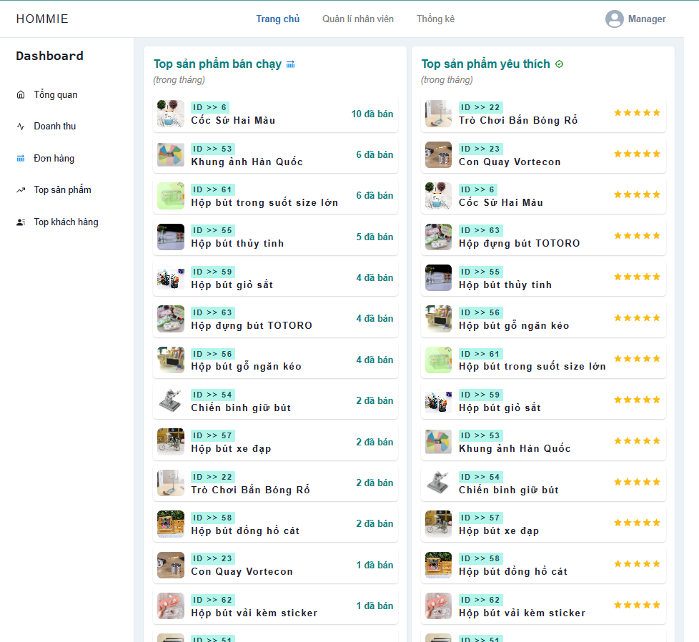

## *Function Details:* View the product statistic of the store by day, week, month and quarter. View the sold, top sale and top rating

**c. <<View storderatistics by order>>**

***Function trigger:*** The default page of the manager page will display the overview of statistics. When the manager clicks ‘Top products’, the function will be triggered.

***Function description:*** This function retrieves and displays statistics and metrics related to orders placed in a system or platform. It provides insights into the overall performance of the ordering process, such as the number of orders, order value, average order size, and other relevant metrics

***Screen layout:***

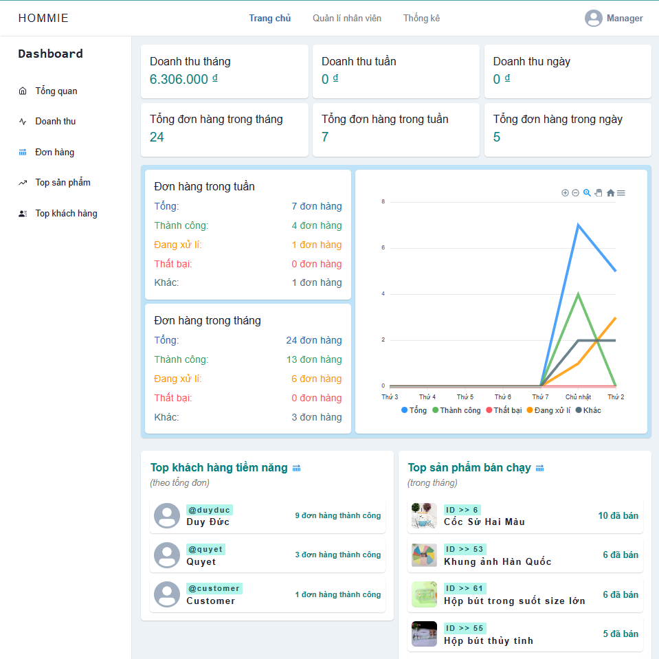

## *Function Details:* View the order statistic of the store by day, week, month and quarter. View the revenue, the number of orders with each status, the number of orders.

**d. <<View statistic by CustomerCustomer>>**

***Function trigger:*** The default page of the manager page will display the overview of statistics. When the manager clicks ‘Customer’, the function will be triggered.

***Function description:*** This function retrieves and displays statistics and metrics related to user activity and behaviour within a system or platform. It provides insights into user engagement, user demographics, user preferences, or any other relevant metrics that help analyse and understand user behaviour

***Screen layout:***

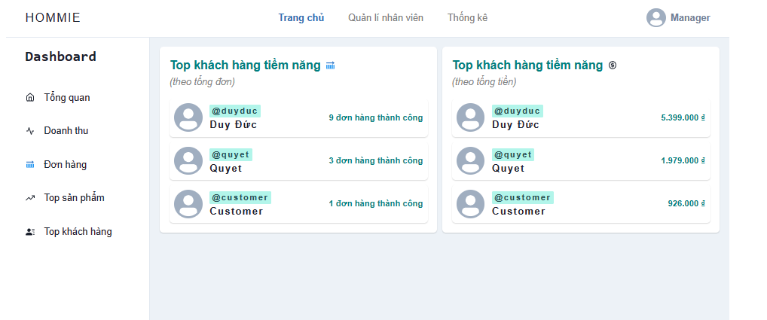

## *Function Details:* View the user statistic of the store by day, week, month and quarter. View the number of product that user buy, potential customers, etc